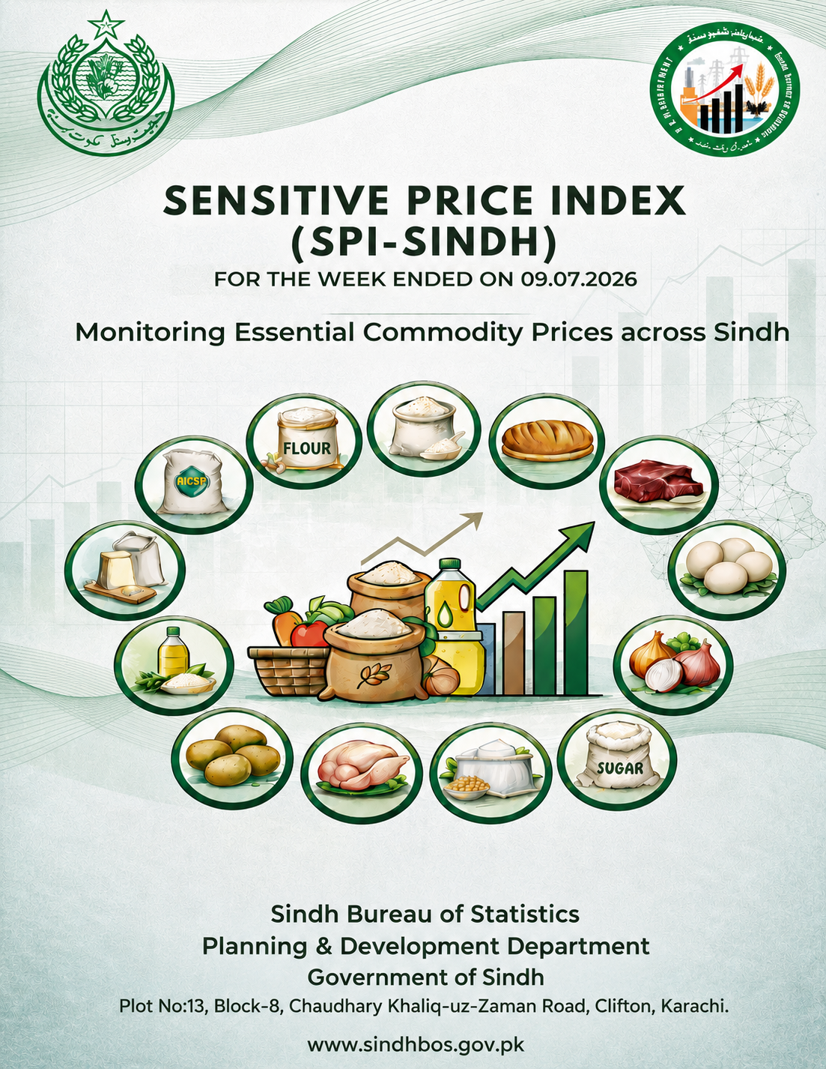

SENSITIVE PRICE INDEX SINDH
(SPI-Sindh)

FOR THE WEEK ENDED ON 09.07.2026

MONITORING ESSENTIAL COMMODITY PRICES ACROSS SINDH

-------------------------------------------------------
Contact us:
SPI Analysis Team
Economics & Price Statistics Section
Sindh Bureau of Statistics
pricestatistics.bos@gmail.com

-------------------------------------------------------



GOVERNMENT OF SINDH
PLANNING & DEVELOPMENT DEPARTMENT
SINDH BUREAU OF STATISTICS
Karachi Dated: 09.07.2026

EXECUTIVE SUMMARY

SENSITIVE PRICE INDEX SINDH (SPI-Sindh) FOR THE WEEK ENDED ON 09.07.2026

Sensitive Price Index of Sindh (SPI-Sindh) has been calculated on a weekly basis to observe the price changes of 50 essential items in Sindh. SPI-Sindh is based on 50 essential items and prices collected from 120 Shops, 60 markets in 30 districts of Sindh (4 shops & 2 markets per district). The prices of Electricity & Gas are obtained from PBS’s SPI report for the same period. The Week on Week (WoW) and Month on Month (MoM) changes in SPI-Sindh are as follows:

Period | 11.06.2026 | 02.07.2026 | 09.07.2026 | %Change Over
 |  |  |  | 02.07.2026 (WoW) | 11.06.2026 (MoM)
SPI-Sindh | 362.94 | 359.26 | 357.34 | -0.53% | -1.54%

As validation strategy, the SPI of Sindh has been cross-checked against PBS price data of four major cities (Karachi, Hyderabad, Sukkur, and Larkana) of Sindh disseminated under National SPI by PBS for the same week ended on 09.07.2026 wherein trend remained comparable and consistent. The SPI for Sindh calculated by SBOS on PBS’s price data of 4 major cities of Sindh disseminated under National SPI for the week-ended on 09.07.2026 is provided hereunder for comparison:

Period | 11.06.2026 | 18.06.2026 | 02.07.2026 | 09.07.2026
SPI based on PBS Data  (4 Major Cities of Sindh) | 372.96 | 373.20 | 369.12 | 366.38
WoW % Change | 0.003 | 0.06 | -1.09 | -0.74

ANALYSIS OF SPI-SINDH:

SPI-Sindh for the current week as on 09.07.2026 decreased by -0.53 percent compared with the previous week, while on a month-on-month (MoM) basis, the index showed an overall decrease of -1.54 percent, indicating continued easing in the prices of essential commodities during both the weekly and monthly periods.
During the current week, a decrease was observed in 20 commodities, with the major decrease recorded in Tomatoes (-17.0%), followed by LPG Cylinder, 11kg (-13.8%), Pulse Masoor, Washed (-1.5%), and Chicken Farm, Broiler, Live (-1.0%). Other notable decreases were observed in Hi Speed Diesel (HSP) (-1.0%), Bread Plain, Medium Size (-0.8%), Mustard Oil, Average Quality (-0.8%), Cigarettes, K-2/Capstan,20's (-0.8%), Sugar, Refined (-0.7%), and Petrol, Super (-0.7%). Moderate declines were also observed in Vegetable Ghee (Loose) (-0.6%), Vegetable Ghee, Tin (-0.4%), Firewood Whole (-0.4%), Energy Saver (14 watts) (-0.4%) and Pulse Moong, Washed (-0.3%). The lowest decreases were recorded in Beef with Bone, Average quality (-0.2%), Powdered Milk, Nido, Polybag (-0.2%), Pulse Mash, Washed (-0.2%) and Long Cloth (-0.2%).
On the other hand, an increase was registered in 15 commodities out of the basket of 50 essential items. The major increase was recorded in Salt Powder, Loose, Lahori (3.2%), followed by Garlic (3.0%), Bananas (2.1%), and Wheat Flour, Bag Average Quality (1.7%). Other notable increases were observed in Red Chilli Powder, Loose (1.3%), Tea Prepared, Average Hotel (1.3%), Rice Basmati Broken, Average Quality (1.0%), and Washing Soap, 200-250 g (1.0%). Moderate increases were also seen in Lawn (0.9%), Rice Irri (Punjab/Sindh) (0.8%), Georgette (0.6%), Cooked Beef, Average Hotel (0.4%), and Sandal Bata (Ladies) (0.4%). Smaller increases were recorded in Sandal Bata (Gents) (0.2%) and Mutton, Average Quality (0.1%).

The prices of 15 commodities remained unchanged, including Milk Fresh (Unboiled), Curd (Dahi), Eggs Hen (Farm), Pulse Gram (Washed), Potatoes, Onions, Gur (Average Quality), Tea (Lipton Yellow Label, Packet), Cooked Daal (Average Hotel), Shirting, Chappal Sponge Bata (Gents), Electricity Charges (Upto 50 Units), Gas Charges (Upto 3.3719 MMBTU), Match Box, Regular, Soap, Lifebuoy.
The weekly trend reflects sharp increases in Salt Powder, Garlic, and Bananas prices, while substantial reductions in petroleum products, LPG, and poultry prices provided significant relief during the week. The MoM indicators also suggest an overall easing in inflationary pressure across essential consumption items in Sindh.
*****
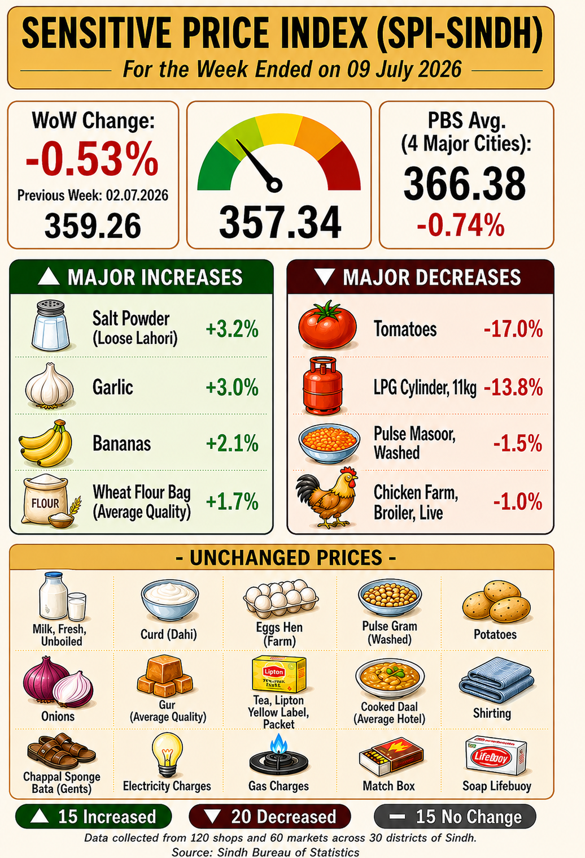
PART-II (SPI REPORT)
CATEGORY-WISE WEEKLY PRICE MOVEMENT IN SPI-SINDH (09.07.2026 OVER 02.07.2026)
The category-wise analysis of the Sensitive Price Index (SPI-Sindh) for the week ended on 9th July 2026 indicates an overall decrease of -0.53 percent compared to the previous week. The decline in the index was primarily driven by a substantial decrease in Vegetables (-7.38%), followed by Tobacco (-0.83%), Fuel & Energy (-0.75%), Sugar & Sweeteners (-0.63%), Oils & Fats (-0.51%), Pulses & Legumes (-0.27%), and Meat & Protein (-0.27%), reflecting downward pressure in both food and non-food categories during the week.
On the other hand, significant increases were observed in Fruits (2.31%), Spices & Condiments (1.84%), and Cereals & Bakery (1.31%), indicating strong upward pressure in perishable food commodities. Moderate increases were also recorded in Tea (0.77%) and Household Supplies (0.43%) during the period.
Meanwhile, only Dairy remained stable with no change (0.00%) during the week. The detailed list of commodities included under each category is provided at Annex-A for reference.
Table 1: SPI-SINDH Week on Week (WoW) Percentage Changes (09.07.2026 OVER 02.07.2026)
S. No. | Category | Items Count |  | WoW Change %
1 | Cereals & Bakery | 4 |  | 1.31
2 | Meat & Protein | 4 |  | -0.27
3 | Dairy | 3 |  | 0.00
4 | Oils & Fats | 4 |  | -0.51
5 | Vegetables | 4 |  | -7.38
6 | Fruits | 1 |  | 2.31
7 | Pulses & Legumes | 4 |  | -0.27
8 | Sugar & Sweeteners | 2 |  | -0.63
9 | Spices & Condiments | 2 |  | 1.84
10 | Tea | 2 |  | 0.77
11 | Prepared Food | 2 |  | 0.13
12 | Tobacco | 1 |  | -0.83
13 | Clothing & Footwear | 7 |  | 0.23
14 | Fuel & Energy | 6 |  | -0.75
15 | Household Supplies | 4 |  | 0.43
 | Total | 50 |  | -0.53

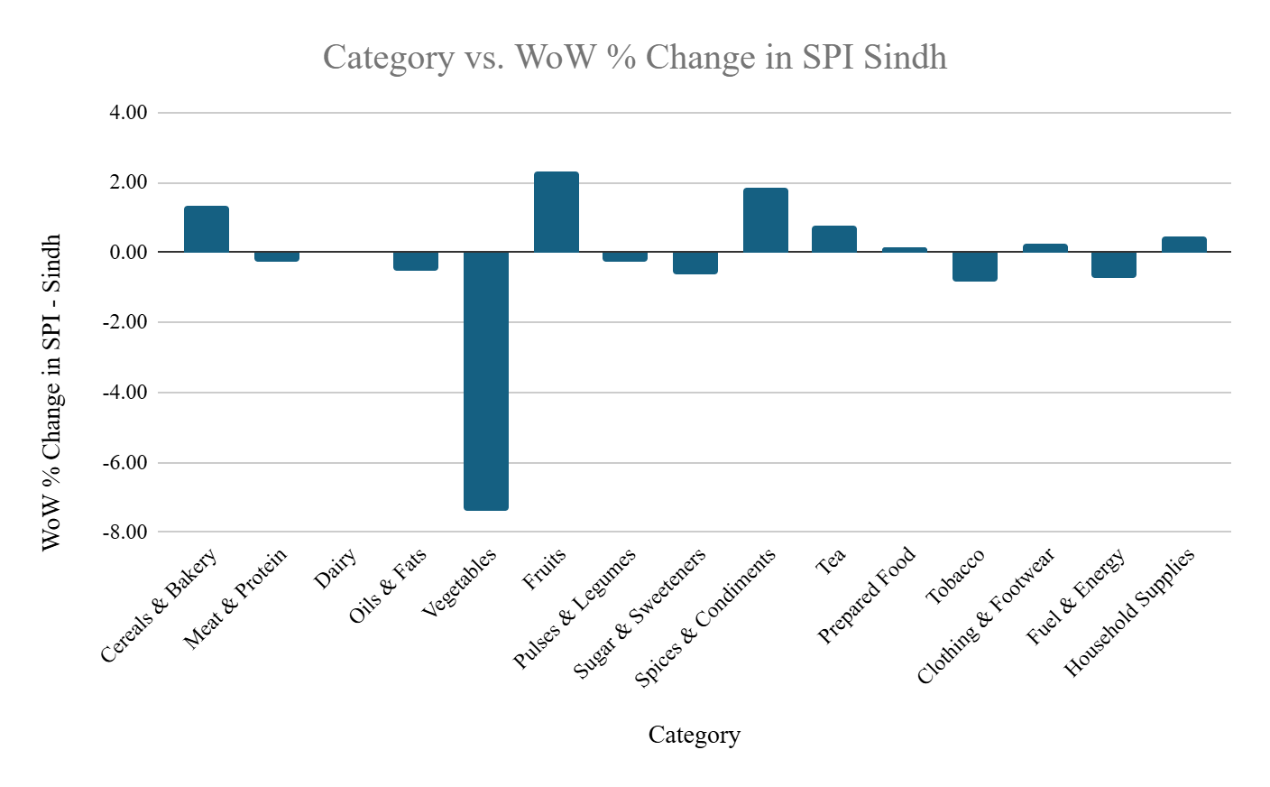

COMPARISON CURRENT WEEK OVER LAST WEEK (09.07.2026 OVER 02.07.2026)

The following table presents the percentage changes in prices of commodities included in the SPI basket between the 2nd week of July 2026 and 1st week of July ended on 9th July 2026.
Table 2 : COMPARISON CURRENT WEEK OVER LAST WEEK (09.07.2026 OVER 02.07.2026)
S. No. | Commodities | Average Prices of All Districts in Sindh |  |  | Percentage Change (%)
S. No. | Commodities | Week Ended On |  |  | Percentage Change (%)
S. No. | Commodities | Unit | 02.07.2026 | 09.07.2026 | Percentage Change (%)
Average Prices of 15 items Registered Increase
1 | Salt Powder, Loose, Lahori | 1 kg | 31 | 32 | 3.2
2 | Garlic | 1 kg | 330 | 340 | 3.0
3 | Bananas | Dozen | 140 | 143 | 2.1
4 | Wheat Flour, Bag Average Quality | 20 kg | 2517 | 2560 | 1.7
5 | Red Chilli Powder, Loose | 1 kg | 670 | 679 | 1.3
6 | Tea Prepared, Average Hotel | Cup | 76 | 77 | 1.3
7 | Rice Basmati Broken, Average Quality | 1 kg | 191 | 193 | 1.0
8 | Washing Soap, 200-250 g | Cake | 104 | 105 | 1.0
9 | Lawn | 1 mtr | 440 | 444 | 0.9
10 | Rice Irri (Punjab/Sindh) | 1 kg | 132 | 133 | 0.8
11 | Georgette | 1 mtr | 319 | 321 | 0.6
12 | Cooked Beef, Average Hotel | Plate | 275 | 276 | 0.4
13 | Sandal Bata (Ladies) | Pair | 1832 | 1839 | 0.4
14 | Sandal Bata (Gents) | Pair | 2474 | 2478 | 0.2
15 | Mutton, Average Quality | 1 kg | 2182 | 2184 | 0.1
Average Prices of 15 items Registered No Change
1 | Milk, Fresh, Unboiled | 1 Ltr | 221 | 221 | 0.0
2 | Curd (Dahi) | 1 kg | 290 | 290 | 0.0
3 | Eggs Hen, Farm | Dozen | 219 | 219 | 0.0
4 | Pulse Gram, Washed | 1 kg | 265 | 265 | 0.0
5 | Potatoes | 1 kg | 52 | 52 | 0.0
6 | Onions | 1 kg | 87 | 87 | 0.0
7 | Gur, Average Quality | 1 kg | 200 | 200 | 0.0
8 | Tea, Lipton Yellow Label, Packet | 170-200 gm | 412 | 412 | 0.0
9 | Cooked Daal, Average Hotel | Plate | 164 | 164 | 0.0
10 | Shirting | 1 mtr | 432 | 432 | 0.0
11 | Chappal Sponge Bata (Gents) | Pair | 943 | 943 | 0.0
12 | Electricity Charges, Upto 50 Units | Unit | 6.95 | 6.95 | 0.0
13 | Gas Charges, Upto 3.3719 MMBTU | MMBTU | 2566.5 | 2567 | 0.0
14 | Match Box, Regular | Each | 6 | 6 | 0.0
15 | Soap, Lifebuoy | Each | 122 | 122 | 0.0
Average Prices of 20 items Registered Decrease
1 | Tomatoes | 1 kg | 288 | 239 | -17.0
2 | LPG Cylinder, 11kg | Each | 4285 | 3692 | -13.8
3 | Pulse Masoor, Washed | 1 kg | 261 | 257 | -1.5
4 | Chicken Farm, Broiler, Live | 1 kg | 303 | 300 | -1.0
5 | Hi Speed Diesel (HSP) | 1 Ltr | 315 | 312 | -1.0
6 | Bread Plain, Medium Size | Each | 126 | 125 | -0.8
7 | Mustard Oil, Average Quality | 1 kg | 525 | 521 | -0.8
8 | Cigarettes, K-2/Capstan,20's | Packet | 256 | 254 | -0.8
9 | Sugar, Refined | 1 kg | 147 | 146 | -0.7
10 | Petrol, Super | 1 Ltr | 302 | 300 | -0.7
11 | Cooking Oil, Tin | 2.5 Ltr | 1438 | 1430 | -0.6
12 | Vegetable Ghee (Loose) | 1 kg | 503 | 500 | -0.6
13 | Vegetable Ghee, Tin | 2.5 kg | 1418 | 1413 | -0.4
14 | Firewood Whole | 40 kg | 957 | 953 | -0.4
15 | Energy Saver (14 watts) | Each | 237 | 236 | -0.4
16 | Pulse Moong, Washed | 1 kg | 382 | 381 | -0.3
17 | Beef with Bone, Average quality | 1 kg | 1249 | 1246 | -0.2
18 | Powdered Milk, Nido, Polybag | 400 gm | 1155 | 1153 | -0.2
19 | Pulse Mash, Washed | 1 kg | 423 | 422 | -0.2
20 | Long Cloth | 1 mtr | 505 | 504 | -0.2

CATEGORY-WISE DIVISION LEVEL ANALYSIS (WoW)
The division-wise analysis of SPI-Sindh reveals notable regional variations in price movements during the current week. At the provincial level, Fruits (2.3%) and Spices & Condiments (2.2%) recorded the highest increases, followed by Tea (0.7%), Cereals & Bakery (0.5%), Clothing & Footwear (0.3%), Prepared Food (0.2%), and Household Supplies (0.2%), indicating moderate upward pressure in selected commodity groups. In contrast, significant declines were observed in Vegetables (-3.3%), Fuel & Energy (-2.5%), Tobacco (-0.8%), Sugar & Sweeteners (-0.4%), Oils & Fats (-0.4%), Meat & Protein (-0.3%), and Pulses & Legumes (-0.3%), which exerted downward pressure on the overall provincial index. Dairy remained broadly stable during the week. These regional variations reflect differences in local supply conditions, seasonal availability, transportation costs, and market dynamics across Karachi, Hyderabad, Sukkur, Larkana, Mirpurkhas, and Shaheed Benazirabad.
Karachi recorded mixed price movements during the week. The highest increases were observed in Fruits (2.3%), followed by Spices & Condiments (2.2%), Clothing & Footwear (1.5%), Cereals & Bakery (1.0%), Tea (1.0%), and Household Supplies (1.0%). However, substantial declines were registered in Vegetables (-6.0%), Pulses & Legumes (-1.9%), Fuel & Energy (-1.8%), Oils & Fats (-1.5%), Sugar & Sweeteners (-0.7%), Prepared Food (-0.6%), Meat & Protein (-0.6%), Dairy (-0.3%), and Tobacco (-0.3%).
Hyderabad displayed varied price movements across commodity groups. Cereals & Bakery (1.0%) recorded the highest increase, followed by Prepared Food (0.7%), Spices & Condiments (0.7%), Household Supplies (0.5%), Dairy (0.3%), Oils & Fats (0.2%), and Clothing & Footwear (0.1%). In contrast, Vegetables (-9.9%) registered the sharpest decline, followed by Fruits (-4.9%), Fuel & Energy (-3.4%), Pulses & Legumes (-1.1%), Meat & Protein (-0.7%), Tea (-0.4%), and Sugar & Sweeteners (-0.3%), while Tobacco remained unchanged.
Sukkur experienced mixed price movements during the week. Significant increases were observed in Spices & Condiments (3.1%), Tea (2.3%), Pulses & Legumes (2.0%), Meat & Protein (1.3%), Cereals & Bakery (0.8%), and Sugar & Sweeteners (0.8%). Conversely, notable declines were recorded in Fruits (-7.0%), Tobacco (-3.7%), Vegetables (-3.3%), Fuel & Energy (-2.5%), Oils & Fats (-0.2%), Clothing & Footwear (-0.2%), and Dairy (-0.1%), while Prepared Food remained unchanged.
Larkana exhibited mixed price movements during the week. The highest increase was observed in Fruits (4.0%), followed by Tea (2.6%), Vegetables (1.6%), Oils & Fats (0.2%), Dairy (0.1%), and Clothing & Footwear (0.1%). However, significant declines were recorded in Fuel & Energy (-2.0%), Sugar & Sweeteners (-1.5%), Spices & Condiments (-1.0%), Meat & Protein (-0.9%), Pulses & Legumes (-0.5%) and Household Supplies (-0.1%), while Cereals & Bakery, Prepared Food, and Tobacco remained broadly unchanged.
Mirpurkhas recorded strong increases in Fruits (21.6%), followed by Vegetables (17.6%), Pulses & Legumes (2.7%), Spices & Condiments (2.3%), Cereals & Bakery (0.6%), Sugar & Sweeteners (0.3%), and Meat & Protein (0.2%). In contrast, notable declines were observed in Fuel & Energy (-3.1%), Oils & Fats (-0.9%), Clothing & Footwear (-0.3%), and Tea (-0.1%), while Dairy, Prepared Food, Tobacco, and Household Supplies remained unchanged.
Shaheed Benazirabad experienced notable increases in Fruits (11.4%), Spices & Condiments (1.5%), and Meat & Protein (0.7%). However, substantial declines were recorded in Vegetables (-5.4%), Fuel & Energy (-2.9%), Oils & Fats (-1.5%), Household Supplies (-1.4%), Cereals & Bakery (-1.2%), Clothing & Footwear (-0.7%), Sugar & Sweeteners (-0.7%), Pulses & Legumes (-0.7%), Tea (-0.6%), and Prepared Food (-0.2%), while Dairy and Tobacco remained unchanged.
Overall, the division-wise analysis indicates that the week's price movements were characterized by a broad decline in Vegetables across most divisions, particularly in Hyderabad, Karachi, Shaheed Benazirabad, and Sukkur, although Mirpurkhas and Larkana recorded notable increases. Fruits exhibited highly divergent regional behaviour, with exceptionally sharp increases in Mirpurkhas, Shaheed Benazirabad, and Larkana, while Hyderabad and Sukkur experienced significant declines. Fuel & Energy continued to record consistent decreases across all divisions, providing relief in energy-related items, whereas Spices & Condiments registered broad-based increases in most regions. These regional disparities continue to reflect localized supply conditions, seasonal factors, and differences in market dynamics across Sindh.
Table 3: Category-wise Division Level WoW Price Changes in percentage (09.07.2026 OVER 02 .07.2026)
 | Category | Items Count | Karachi | Hyderabad | Sukkur | Larkana | Mirpurkhas | Sh. Benazirabad | Sindh
1 | Cereals & Bakery | 4 | 1.0 | 1.0 | 0.8 | 0.0 | 0.6 | -1.2 | 0.5
2 | Meat & Protein | 4 | -0.6 | -0.7 | 1.3 | -0.9 | 0.2 | 0.7 | -0.3
3 | Dairy | 3 | -0.3 | 0.3 | -0.1 | 0.1 | 0.0 | 0.0 | 0.0
4 | Oils & Fats | 4 | -1.5 | 0.2 | -0.2 | 0.2 | -0.9 | -1.5 | -0.4
5 | Vegetables | 4 | -6.0 | -9.9 | -3.3 | 1.6 | 17.6 | -5.4 | -3.3
6 | Fruits | 1 | 2.3 | -4.9 | -7.0 | 4.0 | 21.6 | 11.4 | 2.3
7 | Pulses & Legumes | 4 | -1.9 | -1.1 | 2.0 | -0.5 | 2.7 | -0.7 | -0.3
8 | Sugar & Sweeteners | 2 | -0.7 | -0.3 | 0.8 | -1.5 | 0.3 | -0.7 | -0.4
9 | Spices & Condiments | 2 | 2.2 | 0.7 | 3.1 | -1.0 | 2.3 | 1.5 | 2.2
10 | Tea | 2 | 1.0 | -0.4 | 2.3 | 2.6 | -0.1 | -0.6 | 0.7
11 | Prepared Food | 2 | -0.6 | 0.7 | 0.0 | 0.0 | 0.0 | -0.2 | 0.2
12 | Tobacco | 1 | -0.3 | 0.0 | -3.7 | 0.0 | 0.0 | 0.0 | -0.8
13 | Clothing & Footwear | 7 | 1.5 | 0.1 | -0.2 | 0.1 | -0.3 | -0.7 | 0.3
14 | Fuel & Energy | 6 | -1.8 | -3.4 | -2.5 | -2.0 | -3.1 | -2.9 | -2.5
15 | Household Supplies | 4 | 1.0 | 0.5 | 0.3 | -0.1 | 0.0 | -1.4 | 0.2
Green = Decrease | Grey = No Change | Orange/Red = Increase (Color intensity increases with magnitude of change)
Values represent weighted simple averages of commodity-level week-on-week (%) changes within each category.
The Sindh column represents the provincial average.
CATEGORY-WISE MONTHLY PRICE MOVEMENT IN SPI-SINDH (09.07.2026 OVER 11.06.2026)
The category-wise analysis of the Sensitive Price Index (SPI-Sindh) for the period ending on 9th July 2026 indicates an overall decrease of -1.54 percent compared to 11th June 2026. The decline in the index was primarily driven by substantial decreases in Fuel & Energy (-6.12%), Meat & Protein (-2.47%), and Pulses & Legumes (-0.82%), providing significant relief across major food and non-food consumption groups during the period.
Further notable declines were observed in Oils & Fats (-0.81%), Sugar & Sweeteners (-0.63%), Clothing & Footwear (-0.45%), and Tobacco (-0.41%), indicating easing price pressures in several essential commodity groups.
On the other hand, significant increases were recorded in Vegetables (46.62%), Cereals & Bakery (2.94%), and Tea (0.77%), reflecting strong upward pressure in key food consumption categories. Moderate increases were also observed in Spices & Condiments (0.73%) and Dairy (0.07%) during the period.
Meanwhile, Prepared Food, Fruits, and Household Supplies remained stable with no change (0.00%) during the period. The detailed list of commodities included under each category is provided at Annex-A for reference.
Table 4: SPI-SINDH Month on Month (MoM) Percentage Changes (09.07.2026 OVER 11.06.2026)
S. No. | Category | Items Count | MoM % Change
1 | Cereals & Bakery | 4 | 2.94
2 | Meat & Protein | 4 | -2.47
3 | Dairy | 3 | 0.07
4 | Oils & Fats | 4 | -0.81
5 | Vegetables | 4 | 46.62
6 | Fruits | 1 | 0.00
7 | Pulses & Legumes | 4 | -0.82
8 | Sugar & Sweeteners | 2 | -0.63
9 | Spices & Condiments | 2 | 0.73
10 | Tea | 2 | 0.77
11 | Prepared Food | 2 | 0.00
12 | Tobacco | 1 | -0.41
13 | Clothing & Footwear | 7 | -0.45
14 | Fuel & Energy | 6 | -6.12
15 | Household Supplies | 4 | 0.00
 | Total | 50 | -1.54
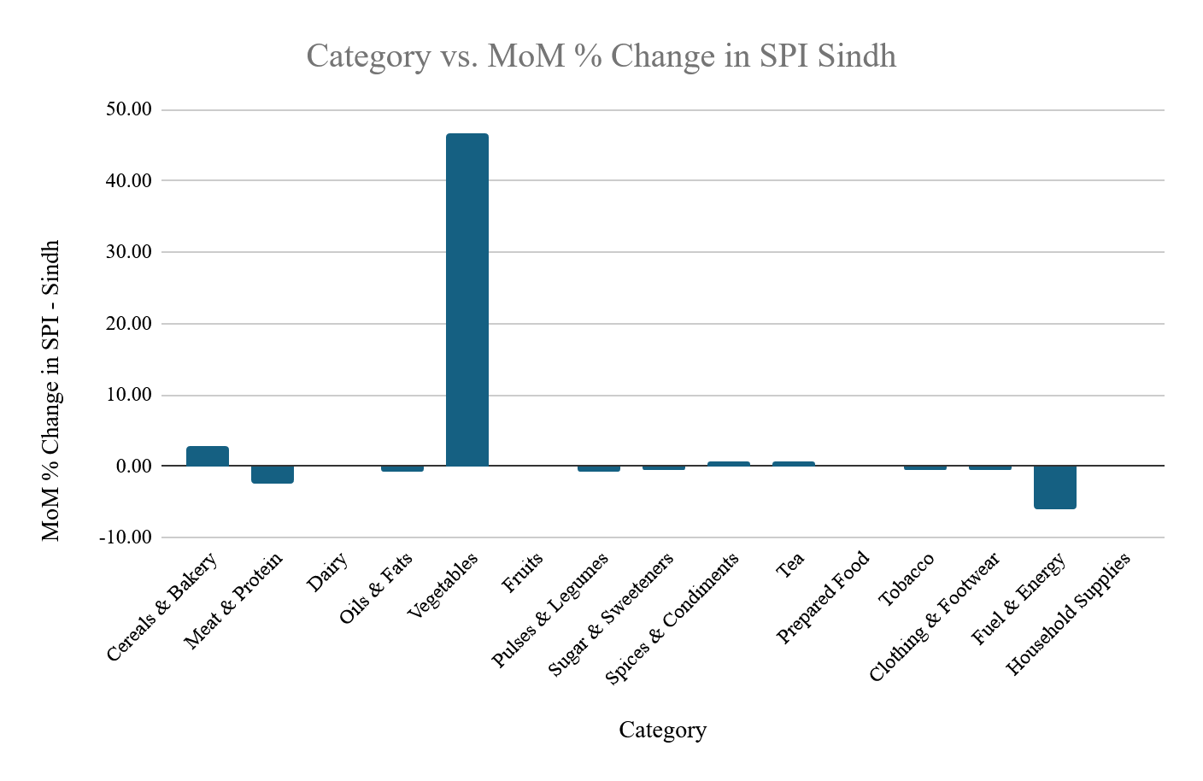

MONTH ON MONTH (MOM) COMPARISON CURRENT WEEK OVER THE CORRESPONDING WEEK (09.07.2026 OVER 11.06.2026)

The following table presents the Month on Month (MoM) percentage changes in prices of commodities included in the SPI basket between the 2nd week of July 2026 and 2nd week of June.
Table 5: COMPARISON CURRENT MONTH OVER LAST MONTH (09.07.2026 OVER 11.06.2026)
S. No. | Commodities | Average Prices of All Districts in Sindh |  |  | Percentage Change (%)
S. No. | Commodities | Week Ended On |  |  | Percentage Change (%)
S. No. | Commodities | Unit | 09.07.2026 | 11.06.2026 | Percentage Change (%)
Average Prices of 13 items Registered Increase
1 | Tomatoes | 1 kg | 239 | 112 | 113.39
2 | Potatoes | 1 kg | 52 | 41 | 26.83
3 | Onions | 1 kg | 87 | 70 | 24.29
4 | Wheat Flour, Bag | 20 kg | 2560 | 2447 | 4.62
5 | Beef with Bone, Average Quality | 1 kg | 1246 | 1222 | 1.96
6 | Mutton, Average Quality | 1 kg | 2184 | 2149 | 1.63
7 | Tea Prepared, Average Hotel | Cup | 77 | 76 | 1.32
8 | Washing Soap, 200-250 gm | Cake | 105 | 104 | 0.96
9 | Red Chilli Powder, Loose | 1 kg | 679 | 673 | 0.89
10 | Cooked Beef, Average Hotel | Plate | 276 | 274 | 0.73
11 | Curd (Dahi) | 1 kg | 290 | 288 | 0.69
12 | Gur, Average Quality | 1 kg | 200 | 199 | 0.5
13 | Chappal Sponge Bata (Gents) | Pair | 943 | 940 | 0.3
Average Prices of 07 items Registered No Change
1 | Milk, Fresh, Unboiled | 1 Ltr | 221 | 221 | 0.0
2 | Bananas | Dozen | 143 | 143 | 0.00
3 | Salt Powder, Loose, Lahori | 1 kg | 32 | 32 | 0.00
4 | Tea, Lipton Yellow Label, Packet | 170-200 gm | 412 | 412 | 0.00
5 | Electricity Charges, Upto 50 Units | Unit | 7 | 7 | 0.00
6 | Match Box, Regular | Each | 6 | 6 | 0.00
7 | Gas Charges, Upto 3.3719 MMBTU | MMBTU | 2567 | 2566.5 | 0.0
Average Prices of 30 items Registered Decrease
1 | LPG Cylinder, 11kg | Each | 3692 | 4737 | -22.06
2 | Petrol, Super | 1 Ltr | 300 | 381 | -21.26
3 | Hi Speed Diesel (HSP) | 1 Ltr | 312 | 384 | -18.75
4 | Chicken Farm, Broiler, Live | 1 kg | 300 | 347 | -13.54
5 | Garlic | 1 kg | 340 | 350 | -2.86
6 | Mustard Oil, Average Quality | 1 kg | 521 | 536 | -2.80
7 | Eggs Hen, Farm | Dozen | 219 | 224 | -2.23
8 | Rice Irri (Punjab/Sindh) | 1 kg | 133 | 135 | -1.48
9 | Pulse Mash, Washed | 1 kg | 422 | 428 | -1.40
10 | Lawn | 1 mtr | 444 | 450 | -1.33
11 | Energy Saver (14 watts) | Each | 236 | 239 | -1.26
12 | Vegetable Ghee (Loose) | 1 kg | 500 | 506 | -1.19
13 | Pulse Gram, Washed | 1 kg | 265 | 268 | -1.12
14 | Shirting | 1 mtr | 432 | 436 | -0.92
15 | Cooking Oil, Tin, Specify Name | 2.5 Ltr | 1430 | 1442 | -0.83
16 | Soap, Lifebuoy | Each | 122 | 123 | -0.81
17 | Bread Plain, Medium Size | Each | 125 | 126 | -0.79
18 | Pulse Masoor, Washed | 1 kg | 257 | 259 | -0.77
19 | Sugar, Refined | 1 kg | 146 | 147 | -0.68
20 | Georgette | 1 mtr | 321 | 323 | -0.62
21 | Cooked Daal, Average Hotel | Plate | 164 | 165 | -0.61
22 | Pulse Moong, Washed | 1 kg | 381 | 383 | -0.52
23 | Rice Basmati Broken, Average Quality | 1 kg | 193 | 194 | -0.52
24 | Sandal Bata (Gents) | Pair | 2478 | 2488 | -0.40
25 | Cigarettes, K-2/Capstan, 20's | Packet | 254 | 255 | -0.39
26 | Sandal Bata (Ladies) | Pair | 1839 | 1846 | -0.38
27 | Firewood Whole | 40 kg | 953 | 955 | -0.21
28 | Long Cloth | 1 mtr | 504 | 505 | -0.20
29 | Powdered Milk, Nido, Polybag | 400 gm | 1153 | 1154 | -0.09
30 | Vegetable Ghee, Tin, Specify Name | 2.5 kg | 1413 | 1414 | -0.07

Annexure-A

S.No. | Categories | No. of Items | Commodity/items
1 | Cereals & Bakery | 4 | Wheat Flour
1 | Cereals & Bakery | 4 | Rice Basmati Broken
1 | Cereals & Bakery | 4 | Rice Irri
1 | Cereals & Bakery | 4 | Bread Plain
2 | Clothing & Footwear | 7 | Long Cloth
2 | Clothing & Footwear | 7 | Shirting
2 | Clothing & Footwear | 7 | Lawn
2 | Clothing & Footwear | 7 | Georgette
2 | Clothing & Footwear | 7 | Sandal Bata Gents
2 | Clothing & Footwear | 7 | Chappal Sponge Gents
2 | Clothing & Footwear | 7 | Sandal Bata Ladies
3 | Dairy | 3 | Milk Fresh
3 | Dairy | 3 | Curd (Dahi)
3 | Dairy | 3 | Powdered Milk Nido
4 | Fruits | 1 | Bananas
5 | Fuel & Energy | 6 | Electricity Charges
5 | Fuel & Energy | 6 | Gas Charges
5 | Fuel & Energy | 6 | Firewood
5 | Fuel & Energy | 6 | Petrol Super
5 | Fuel & Energy | 6 | Hi Speed Diesel
5 | Fuel & Energy | 6 | LPG Cylinder
6 | Household Supplies | 4 | Energy Saver
6 | Household Supplies | 4 | Washing Soap
6 | Household Supplies | 4 | Match Box
6 | Household Supplies | 4 | Soap Lifebuoy
7 | Meat & Protein | 4 | Beef with Bone
7 | Meat & Protein | 4 | Mutton
7 | Meat & Protein | 4 | Chicken Farm
7 | Meat & Protein | 4 | Eggs Hen Farm
8 | Oils & Fats | 4 | Mustard Oil
8 | Oils & Fats | 4 | Cooking Oil Tin
8 | Oils & Fats | 4 | Vegetable Ghee Tin
8 | Oils & Fats | 4 | Vegetable Ghee Loose
9 | Prepared Food | 2 | Cooked Beef Hotel
9 | Prepared Food | 2 | Cooked Daal Hotel
10 | Pulses & Legumes | 4 | Pulse Masoor
10 | Pulses & Legumes | 4 | Pulse Moong
10 | Pulses & Legumes | 4 | Pulse Mash
10 | Pulses & Legumes | 4 | Pulse Gram
11 | Spices & Condiments | 2 | Salt Powder
11 | Spices & Condiments | 2 | Red Chili Powder
12 | Sugar & Sweeteners | 2 | Sugar Refined
12 | Sugar & Sweeteners | 2 | Gur
13 | Tea | 2 | Tea Lipton
13 | Tea | 2 | Tea Prepared Hotel
14 | Tobacco | 1 | Cigarettes K-2/Capstan
15 | Vegetables | 4 | Potatoes
15 | Vegetables | 4 | Onions
15 | Vegetables | 4 | Tomatoes
15 | Vegetables | 4 | Garlic
Annexure-B
Average Prices of 50 Essential Commodities in 30 Districts of Sindh as on 09th July 2026

S No. | Description | Unit | Karachi South | Karachi West | Karachi East | Karachi Central | Korangi | Keamari | Malir
1 | Wheat Flour, Bag Average Quality | 20 kg | 2725 | 2800 | 2579 | 2612 | 2375 | 2700 | 2600
2 | Rice Basmati Broken, Average Quality | 1 kg | 237 | 272 | 192 | 230 | 250 | 235 | 285
3 | Rice Irri (Punjab/Sindh) | 1 kg | 162 | 195 | 120 | 185 | 110 | 180 | 187
4 | Bread Plain, Medium Size | Each | 114 | 120 | 130 | 130 | 110 | 120 | 105
5 | Beef with Bone, Average quality | 1 kg | 1345 | 1600 | 1300 | 1524 | 1349 | 1500 | 1300
6 | Mutton, Average Quality | 1 kg | 2540 | 2600 | 2425 | 2550 | 2098 | 2698 | 2375
7 | Chicken Farm, Broiler, Live | 1 kg | 315 | 325 | 325 | 310 | 280 | 275 | 292
8 | Milk, Fresh, Unboiled | 1 Ltr | 240 | 240 | 240 | 240 | 240 | 240 | 240
9 | Curd (Dahi) | 1 kg | 360 | 355 | 360 | 370 | 360 | 400 | 360
10 | Powdered Milk, Nido, Polybag | 400 gm | 1075 | 1200 | 1125 | 1087 | 1125 | 1200 | 1100
11 | Eggs Hen, Farm | Dozen | 224 | 195 | 237 | 230 | 210 | 210 | 240
12 | Mustard Oil, Average Quality | 1 kg | 587 | 545 | 600 | 600 | 577 | 600 | 600
13 | Cooking Oil, Tin | 2.5 Ltr | 1425 | 1525 | 1406 | 1425 | 1150 | 1550 | 1390
14 | Vegetable Ghee, Tin | 2.5 kg | 1500 | 1550 | 1406 | 1500 | 1400 | 1520 | 1425
15 | Vegetable Ghee (Loose) | 1 kg | 535 | 545 | 575 | 545 | 550 | 492 | 490
16 | Bananas | Dozen | 173 | 182 | 115 | 150 | 173 | 173 | 150
17 | Pulse Masoor, Washed | 1 kg | 241 | 360 | 240 | 242 | 220 | 230 | 210
18 | Pulse Moong, Washed | 1 kg | 390 | 400 | 387 | 395 | 360 | 355 | 370
19 | Pulse Mash, Washed | 1 kg | 415 | 480 | 440 | 420 | 345 | 402 | 405
20 | Pulse Gram, Washed | 1 kg | 235 | 360 | 240 | 225 | 225 | 242 | 230
21 | Potatoes | 1 kg | 62 | 45 | 57 | 47 | 50 | 50 | 70
22 | Onions | 1 kg | 99 | 75 | 95 | 82 | 70 | 89 | 80
23 | Tomatoes | 1 kg | 213 | 207 | 232 | 245 | 224 | 237 | 255
24 | Sugar, Refined | 1 kg | 146 | 150 | 150 | 149 | 143 | 150 | 150
25 | Gur, Average Quality | 1 kg | 230 | 245 | 235 | 242 | 250 | 220 | 210
26 | Salt Powder, Loose, Lahori | 1 kg | 50 | 35 | 62 | 60 | 20 | 30 | 40
27 | Red Chili Powder, Loose | 1 kg | 865 | 894 | 800 | 924 | 600 | 649 | 700
28 | Garlic | 1 kg | 468 | 372 | 412 | 400 | 355 | 247 | 345
29 | Tea, Lipton Yellow Label, Packet | 170-200 gm | 397 | 400 | 392 | 395 | 385 | 400 | 395
30 | Cooked Beef, Average Hotel | Plate | 224 | 252 | 345 | 374 | 320 | 324 | 310
31 | Cooked Daal, Average Hotel | Plate | 140 | 155 | 199 | 172 | 200 | 150 | 210
32 | Tea Prepared, Average Hotel | Cup | 75 | 80 | 80 | 85 | 70 | 75 | 89
33 | Cigarettes, K-2/Capstan,20's | Packet | 260 | 240 | 257 | 260 | 250 | 260 | 255
34 | Long Cloth | 1 mtr | 812 | 800 | 624 | 800 | 400 | 650 | 749
35 | Shirting | 1 mtr | 398 | 600 | 599 | 700 | 350 | 450 | 636
36 | Lawn | 1 mtr | 749 | 592 | 636 | 762 | 675 | 400 | 725
37 | Georgette | 1 mtr | 335 | 600 | 424 | 300 | 725 | 350 | 500
38 | Sandal Bata (Gents) | Pair | 2958 | 1999 | 2424 | 3500 | 2500 | 3499 | 2500
39 | Chappal Sponge Bata (Gents) | Pair | 912 | 1499 | 699 | 1149 | 700 | 1200 | 700
40 | Sandal Bata (Ladies) | Pair | 2236 | 1799 | 2030 | 2475 | 2000 | 3300 | 2000
41 | Electricity Charges, Upto 50 Units | Unit | 6.95 | 6.95 | 6.95 | 6.95 | 6.95 | 6.95 | 6.95
42 | Gas Charges, Upto 3.3719 MMBTU | MMBTU | 2566.5 | 2566.5 | 2566.5 | 2566.5 | 2566.5 | 2566.5 | 2566.5
43 | Firewood Whole | 40 kg | 1400 | 1549 | .. | 1400 | 1200 | 1200 | 1200
44 | Energy Saver (14 watts) | Each | 262 | 250 | 175 | 242 | 250 | 300 | 175
45 | Washing Soap, 200-250 g, Specify Name | Cake | 137 | 145 | 130 | 130 | 89 | 100 | 120
46 | Match Box, Regular | Each | 5 | 6 | 7 | 6 | 7 | 7 | 7
47 | Petrol, Super | 1 Ltr | 299 | 299 | 298 | 299 | 299 | 299 | 299
48 | Hi Speed Diesel (HSP) | 1 Ltr | 311 | 311 | 311 | 311 | 311 | 311 | 311
49 | LPG Cylinder, 11kg | Each | 3461 | 3960 | 3575 | 3300 | 4410 | 3410 | 3520
50 | Soap, Lifebuoy | Each | 130 | 130 | 127 | 130 | 110 | 100 | 100
Note: (..) = Currently unavailable/Limited availability
Continued

S No. | Description | Unit | Hyderabad | Badin | Jamshoro | Tando. Allahyar | Tando Muhammad Khan | Thatta | Sujawal | Dadu | Matiari
1 | Wheat Flour, Bag Average Quality | 20 kg | 2840 | 2800 | 2600 | 2449 | 2562 | 2745 | 2712 | 2600 | 2650
2 | Rice Basmati Broken, Average Quality | 1 kg | 275 | 145 | 140 | 220 | 200 | 210 | 217 | 200 | 199
3 | Rice Irri (Punjab/Sindh) | 1 kg | 125 | 115 | 96 | 100 | 160 | 107 | 114 | 180 | 95
4 | Bread Plain, Medium Size | Each | 120 | 100 | 120 | 130 | 125 | 120 | 120 | 160 | 120
5 | Beef with Bone, Average Quality | 1 kg | 1300 | 1200 | 1300 | 1200 | 1200 | 1098 | 1149 | 1100 | 1300
6 | Mutton, Average Quality | 1 kg | 2474 | 2249 | 2249 | 2000 | 2049 | 1873 | 2000 | 1900 | 2400
7 | Chicken Farm, Broiler, Live | 1 kg | 300 | 300 | 295 | 246 | 320 | 335 | 340 | 350 | 300
8 | Milk, Fresh, Unboiled | 1 Ltr | 240 | 220 | 220 | 210 | 220 | 210 | 205 | 220 | 225
9 | Curd (Dahi) | 1 kg | 339 | 270 | 310 | 290 | 290 | 235 | 227 | 260 | 340
10 | Powdered Milk, Nido, Polybag | 400 gm | 1130 | 1150 | 1150 | 1160 | 1150 | 1160 | 1175 | 1150 | 1140
11 | Eggs Hen, Farm | Dozen | 230 | 210 | 210 | 210 | 210 | 210 | 205 | 250 | 230
12 | Mustard Oil, Average Quality | 1 kg | 450 | 675 | 510 | 486 | 644 | 574 | 670 | 500 | 450
13 | Cooking Oil, Tin | 2.5 Ltr | 1450 | 1365 | 1280 | 1473 | 1445 | 1550 | 1522 | 1580 | 1440
14 | Vegetable Ghee, Tin | 2.5 kg | 1420 | 1415 | 1420 | 1420 | 1400 | 1562 | 1472 | 1560 | 1420
15 | Vegetable Ghee (Loose) | 1 kg | 465 | 475 | 500 | 470 | 510 | 490 | 482 | 550 | 460
16 | Bananas | Dozen | 95 | 134 | 120 | 100 | 155 | 147 | 140 | 150 | 110
17 | Pulse Masoor, Washed | 1 kg | 235 | 290 | 210 | 225 | 275 | 205 | 275 | 300 | 260
18 | Pulse Moong, Washed | 1 kg | 315 | 390 | 350 | 362 | 365 | 367 | 367 | 420 | 370
19 | Pulse Mash, Washed | 1 kg | 395 | 470 | 420 | 390 | 420 | 410 | 467 | 450 | 380
20 | Pulse Gram, Washed | 1 kg | 215 | 290 | 320 | 240 | 259 | 210 | 270 | 355 | 235
21 | Potatoes | 1 kg | 55 | 45 | 50 | 45 | 40 | 50 | 65 | 40 | 60
22 | Onions | 1 kg | 95 | 65 | 90 | 77 | 72 | 75 | 92 | 150 | 90
23 | Tomatoes | 1 kg | 235 | 310 | 290 | 200 | 205 | 230 | 210 | 200 | 240
24 | Sugar, Refined | 1 kg | 135 | 145 | 142 | 140 | 150 | 150 | 150 | 150 | 135
25 | Gur, Average Quality | 1 kg | 185 | 230 | 175 | 175 | 220 | 185 | 205 | 200 | 185
26 | Salt Powder, Loose, Lahori | 1 kg | 30 | 30 | 20 | 60 | 40 | 35 | 35 | 30 | 20
27 | Red Chili Powder, Loose | 1 kg | 675 | 825 | 547 | 574 | 649 | 582 | 672 | 550 | 680
28 | Garlic | 1 kg | 245 | 200 | 320 | 235 | 424 | 389 | 400 | 350 | 255
29 | Tea, Lipton Yellow Label, Packet | 170-200 gm | 400 | 400 | 380 | 400 | 400 | 447 | 435 | 470 | 400
30 | Cooked Beef, Average Hotel | Plate | 340 | 200 | 235 | 255 | 300 | 306 | 345 | 250 | 280
31 | Cooked Daal, Average Hotel | Plate | 164 | 150 | 150 | 170 | 200 | 171 | 240 | 180 | 150
32 | Tea Prepared, Average Hotel | Cup | 72 | 65 | 75 | 72 | 75 | 70 | 75 | 62 | 70
33 | Cigarettes, K-2/Capstan, 20's | Packet | 250 | 255 | 250 | 250 | 250 | 257 | 265 | 260 | 250
34 | Long Cloth | 1 mtr | 610 | 360 | 550 | 400 | 548 | 345 | 387 | 450 | 610
35 | Shirting | 1 mtr | 400 | 374 | 474 | 450 | 548 | 445 | 440 | 424 | 490
36 | Lawn | 1 mtr | 400 | 424 | 374 | 412 | 365 | 440 | 412 | 350 | 390
37 | Georgette | 1 mtr | 280 | 346 | 260 | 400 | 300 | 220 | 262 | 324 | 290
38 | Sandal Bata (Gents) | Pair | 2999 | 1648 | 2999 | 2719 | 2999 | 2600 | 2500 | 2799 | 2999
39 | Chappal Sponge Bata (Gents) | Pair | 1199 | 1148 | 449 | 1070 | 999 | 700 | 1800 | 899 | 449
40 | Sandal Bata (Ladies) | Pair | 1299 | 2248 | 2249 | 2095 | 2800 | 1400 | 2300 | 1150 | 1199
41 | Electricity Charges, Upto 50 Units | Unit | 6.95 | 6.95 | 6.95 | 6.95 | 6.95 | 6.95 | 6.95 | 6.95 | 6.95
42 | Gas Charges, Upto 3.3719 MMBTU | MMBTU | 2566.5 | 2566.5 | 2566.5 | 2566.5 | 2566.5 | 2566.5 | 2566.5 | 2566.5 | 2566.5
43 | Firewood Whole | 40 kg | 800 | 624 | 1050 | 800 | 825 | 712 | 744 | 1000 | 849
44 | Energy Saver (14 watts) | Each | 400 | 374 | 250 | 220 | 250 | 324 | 352 | 300 | 150
45 | Washing Soap, 200-250 g | Cake | 97 | 110 | 100 | 100 | 130 | 120 | 100 | 120 | 100
46 | Match Box, Regular | Each | 5 | 5 | 5 | 5 | 7 | 5 | 6 | 6 | 5
47 | Petrol, Super | 1 Ltr | 301 | 302 | 298 | 302 | 302 | 300 | 302 | 303 | 302
48 | Hi Speed Diesel (HSP) | 1 Ltr | 313 | 314 | 310 | 314 | 314 | 313 | 314 | 314 | 314
49 | LPG Cylinder, 11kg | Each | 3520 | 4180 | 3300 | 3500 | 3300 | 3410 | 3505 | 4200 | 3520
50 | Soap, Lifebuoy | Each | 125 | 110 | 125 | 130 | 135 | 130 | 129 | 130 | 127
Continued
S No. | Description | Unit | Larkana | Shikarpur | Jacobabad | Kambar @ Shahdadkot | Kashmore @ Kandhkot | Shaheed. Benazirabad | Sanghar | N.  Feroze
1 | Wheat Flour, Bag Average Quality | 20 kg | 2050 | 2550 | 2375 | 2498 | 2287 | 2462 | 2600 | 2200
2 | Rice Basmati Broken, Average Quality | 1 kg | 180 | 134 | 165 | 155 | 170 | 132 | 190 | 160
3 | Rice Irri (Punjab/Sindh) | 1 kg | 140 | 110 | 112 | 115 | 122 | 122 | 140 | 130
4 | Bread Plain, Medium Size | Each | 140 | 105 | 150 | 160 | 140 | 135 | 100 | 150
5 | Beef with Bone, Average Quality | 1 kg | 1225 | 1149 | 1200 | 1249 | 1200 | 1199 | 1300 | 1200
6 | Mutton, Average Quality | 1 kg | 2100 | 2200 | 2200 | 1897 | 2212 | 2362 | 2200 | 1900
7 | Chicken Farm, Broiler, Live | 1 kg | 365 | 286 | 285 | 340 | 297 | 255 | 258 | 340
8 | Milk, Fresh, Unboiled | 1 Ltr | 245 | 212 | 245 | 230 | 237 | 215 | 200 | 200
9 | Curd (Dahi) | 1 kg | 280 | 257 | 320 | 310 | 300 | 310 | 230 | 290
10 | Powdered Milk, Nido, Polybag | 400 gm | 1100 | 1170 | 1220 | 1140 | 1200 | 1205 | 1150 | 1120
11 | Eggs Hen, Farm | Dozen | 230 | 180 | 180 | 225 | 220 | 210 | 240 | 230
12 | Mustard Oil, Average Quality | 1 kg | 490 | 480 | 490 | 510 | 507 | 432 | 470 | 480
13 | Cooking Oil, Tin | 2.5 Ltr | 1325 | 1400 | 1500 | 1400 | 1507 | 1375 | 1350 | 1470
14 | Vegetable Ghee, Tin | 2.5 kg | 1075 | 1400 | 1450 | 1180 | 1505 | 1425 | 1350 | 1350
15 | Vegetable Ghee (Loose) | 1 kg | 405 | 480 | 550 | 475 | 557 | 417 | 500 | 500
16 | Bananas | Dozen | 140 | 173 | 200 | 145 | 195 | 124 | 122 | 120
17 | Pulse Masoor, Washed | 1 kg | 280 | 280 | 270 | 225 | 292 | 255 | 240 | 230
18 | Pulse Moong, Washed | 1 kg | 360 | 440 | 385 | 400 | 392 | 370 | 370 | 400
19 | Pulse Mash, Washed | 1 kg | 360 | 450 | 380 | 372 | 400 | 460 | 395 | 430
20 | Pulse Gram, Washed | 1 kg | 325 | 280 | 260 | 225 | 287 | 265 | 281 | 240
21 | Potatoes | 1 kg | 35 | 50 | 77 | 50 | 77 | 49 | 60 | 40
22 | Onions | 1 kg | 70 | 80 | 100 | 89 | 95 | 95 | 80 | 80
23 | Tomatoes | 1 kg | 200 | 240 | 200 | 290 | 277 | 222 | 200 | 200
24 | Sugar, Refined | 1 kg | 160 | 140 | 140 | 150 | 145 | 144 | 150 | 140
25 | Gur, Average Quality | 1 kg | 185 | 183 | 172 | 175 | 167 | 189 | 180 | 190
26 | Salt Powder, Loose, Lahori | 1 kg | 20 | 30 | 30 | 39 | 40 | 34 | 20 | 20
27 | Red Chili Powder, Loose | 1 kg | 550 | 635 | 490 | 574 | 512 | 702 | 600 | 800
28 | Garlic | 1 kg | 385 | 296 | 245 | 447 | 257 | 337 | 346 | 400
29 | Tea, Lipton Yellow Label, Packet | 170-200 gm | 420 | 400 | 480 | 380 | 400 | 405 | 400 | 447
30 | Cooked Beef, Average Hotel | Plate | 400 | 200 | 250 | 290 | 237 | 252 | 320 | 250
31 | Cooked Daal, Average Hotel | Plate | 190 | 127 | 150 | 155 | 157 | 182 | 180 | 230
32 | Tea Prepared, Average Hotel | Cup | 89 | 65 | 100 | 77 | 80 | 74 | 80 | 100
33 | Cigarettes, K-2/Capstan, 20's | Packet | 250 | 245 | 250 | 257 | 270 | 262 | 270 | 260
34 | Long Cloth | 1 mtr | 450 | 490 | 315 | 375 | 360 | 574 | 600 | 450
35 | Shirting | 1 mtr | 300 | 548 | 264 | 300 | 417 | 549 | 274 | 300
36 | Lawn | 1 mtr | 640 | 263 | 300 | 456 | 415 | 574 | 350 | 350
37 | Georgette | 1 mtr | 350 | 173 | 247 | 345 | 375 | 574 | 270 | 250
38 | Sandal Bata (Gents) | Pair | 2350 | 1499 | 2599 | 2500 | 1599 | 2350 | 2098 | 2600
39 | Chappal Sponge Bata (Gents) | Pair | 550 | 599 | 1448 | 1500 | 1199 | 1412 | 700 | 750
40 | Sandal Bata (Ladies) | Pair | 2499 | 1499 | 2324 | 1400 | 1499 | 1999 | 2500 | 1300
41 | Electricity Charges, Upto 50 Units | Unit | 6.95 | 6.95 | 6.95 | 6.95 | 6.95 | 6.95 | 6.95 | 6.95
42 | Gas Charges, Upto 3.3719 MMBTU | MMBTU | 2566.5 | 2566.5 | 2566.5 | 2566.5 | 2566.5 | 2566.5 | 2566.5 | 2566.5
43 | Firewood Whole | 40 kg | 1300 | 1100 | 1225 | 748 | 1087 | 875 | 800 | 1100
44 | Energy Saver (14 watts) | Each | 180 | 296 | 195 | 170 | 217 | 145 | 293 | 200
45 | Washing Soap, 200-250 g | Cake | 70 | 71 | 100 | 120 | 120 | 117 | 110 | 120
46 | Match Box, Regular | Each | 5 | 5 | 6 | 5 | 7 | 6 | 5 | 5
47 | Petrol, Super | 1 Ltr | 301 | 299 | 300 | 300 | 299 | 300 | 301 | 297
48 | Hi Speed Diesel (HSP) | 1 Ltr | 311 | 311 | 312 | 312 | 312 | 312 | 315 | 309
49 | LPG Cylinder, 11kg | Each | 4290 | 3520 | 4099 | 3520 | 4149 | 3355 | 3188 | 4250
50 | Soap, Lifebuoy | Each | 100 | 130 | 130 | 130 | 130 | 122 | 130 | 125
Continued
S No. | Description | Unit | Mirpurkhas | Umerkot | Thar @ Mithi | Sukkur | Khairpur | Ghotki | Min | Average | Max
1 | Wheat Flour, Bag Average Quality | 20 kg | 2600 | 2600 | 2800 | 2575 | 2550 | 2500 | 2050 | 2560 | 2840
2 | Rice Basmati Broken, Average Quality | 1 kg | 180 | 150 | 215 | 230 | 204 | 147 | 132 | 193 | 285
3 | Rice Irri (Punjab/Sindh) | 1 kg | 150 | 130 | 140 | 195 | .. | 105 | 95 | 133 | 195
4 | Bread Plain, Medium Size | Each | 140 | 130 | 120 | 100 | 127 | 140 | 100 | 125 | 160
5 | Beef with Bone, Average Quality | 1 kg | 1200 | 1100 | … | 1200 | 1174 | 1124 | 1098 | 1246 | 1600
6 | Mutton, Average Quality | 1 kg | 2200 | 1900 | 2049 | 2000 | 2000 | 2175 | 1873 | 2184 | 2698
7 | Chicken Farm, Broiler, Live | 1 kg | 242 | 248 | 295 | 330 | 300 | 300 | 242 | 300 | 365
8 | Milk, Fresh, Unboiled | 1 Ltr | 200 | 200 | 195 | 200 | 230 | 200 | 195 | 221 | 245
9 | Curd (Dahi) | 1 kg | 240 | 230 | 195 | 240 | 260 | 240 | 195 | 290 | 400
10 | Powdered Milk, Nido, Polybag | 400 gm | 1200 | 1250 | 1100 | 1150 | 1160 | 1160 | 1075 | 1153 | 1250
11 | Eggs Hen, Farm | Dozen | 200 | 220 | 272 | 210 | 235 | 240 | 180 | 219 | 272
12 | Mustard Oil, Average Quality | 1 kg | 460 | 480 | 482 | 455 | 510 | 450 | 432 | 521 | 675
13 | Cooking Oil, Tin | 2.5 Ltr | 1520 | 1500 | 1235 | 1410 | 1550 | 1500 | 1150 | 1430 | 1580
14 | Vegetable Ghee, Tin | 2.5 kg | 1520 | 1500 | 1205 | 1390 | 1390 | 1400 | 1075 | 1413 | 1562
15 | Vegetable Ghee (Loose) | 1 kg | 500 | 500 | 470 | 555 | 535 | 480 | 405 | 500 | 575
16 | Bananas | Dozen | 120 | 150 | 145 | 150 | 150 | 152 | 95 | 143 | 200
17 | Pulse Masoor, Washed | 1 kg | 300 | 280 | 285 | 265 | 300 | 255 | 205 | 257 | 360
18 | Pulse Moong, Washed | 1 kg | 400 | 395 | 375 | 410 | 400 | 397 | 315 | 381 | 440
19 | Pulse Mash, Washed | 1 kg | 450 | 500 | 425 | 495 | 465 | 435 | 345 | 422 | 500
20 | Pulse Gram, Washed | 1 kg | 300 | 350 | 290 | 290 | 270 | 240 | 210 | 265 | 360
21 | Potatoes | 1 kg | 45 | 50 | 95 | 50 | 50 | 47 | 35 | 52 | 95
22 | Onions | 1 kg | 90 | 100 | 107 | 80 | 100 | 77 | 65 | 87 | 150
23 | Tomatoes | 1 kg | 280 | 300 | 390 | 250 | 250 | 222 | 200 | 239 | 390
24 | Sugar, Refined | 1 kg | 145 | 150 | 146 | 145 | 147 | 145 | 135 | 146 | 160
25 | Gur, Average Quality | 1 kg | 200 | 200 | 195 | 200 | 200 | 197 | 167 | 200 | 250
26 | Salt Powder, Loose, Lahori | 1 kg | 30 | 25 | 45 | 30 | 30 | 20 | 20 | 32 | 62
27 | Red Chili Powder, Loose | 1 kg | 700 | 700 | 790 | 925 | 748 | 774 | 490 | 679 | 925
28 | Garlic | 1 kg | 340 | 350 | 377 | 400 | 374 | 475 | 200 | 340 | 475
29 | Tea, Lipton Yellow Label, Packet | 170-200 gm | 385 | 400 | 475 | 400 | 447 | 447 | 380 | 412 | 480
30 | Cooked Beef, Average Hotel | Plate | 250 | … | … | 200 | 274 | … | 200 | 276 | 400
31 | Cooked Daal, Average Hotel | Plate | 175 | 150 | 167 | 145 | 100 | 100 | 100 | 164 | 240
32 | Tea Prepared, Average Hotel | Cup | 80 | 70 | 75 | 80 | 75 | 80 | 62 | 77 | 100
33 | Cigarettes, K-2/Capstan, 20's | Packet | 250 | 250 | 250 | 250 | 250 | 250 | 240 | 254 | 270
34 | Long Cloth | 1 mtr | 402 | 550 | 312 | 673 | 560 | 505 | 312 | 504 | 812
35 | Shirting | 1 mtr | 648 | 500 | 424 | 622 | 277 | 272 | 264 | 432 | 700
36 | Lawn | 1 mtr | 350 | 390 | 267 | 823 | 318 | 405 | 263 | 444 | 823
37 | Georgette | 1 mtr | 250 | 300 | 287 | 350 | 230 | 230 | 173 | 321 | 725
38 | Sandal Bata (Gents) | Pair | 2999 | 2300 | 2098 | 2999 | 1499 | 2999 | 1499 | 2478 | 3500
39 | Chappal Sponge Bata (Gents) | Pair | 2199 | 1700 | 1549 | 600 | 599 | 600 | 449 | 943 | 2199
40 | Sandal Bata (Ladies) | Pair | 1499 | 1200 | 2000 | 2999 | 1150 | 1299 | 1150 | 1839 | 3300
41 | Electricity Charges, Upto 50 Units | Unit | 6.95 | 6.95 | 6.95 | 6.95 | 6.95 | 6.95 | 6.95 | 6.95 | 6.95
42 | Gas Charges, Upto 3.3719 MMBTU | MMBTU | 2566.5 | 2566.5 | 2566.5 | 2566.5 | 2566.5 | 2566.5 | 2566.5 | 2566.5 | 2566.5
43 | Firewood Whole | 40 kg | 800 | 660 | 661 | 630 | 1149 | 1100 | 624 | 953 | 1549
44 | Energy Saver (14 watts) | Each | 250 | 200 | 225 | 260 | 247 | 180 | 145 | 236 | 400
45 | Washing Soap, 200-250 g | Cake | 60 | 100 | 95 | 100 | 90 | 100 | 60 | 105 | 145
46 | Match Box, Regular | Each | 5 | 7 | 7 | 5 | 5 | 5 | 5 | 6 | 7
47 | Petrol, Super | 1 Ltr | 302 | 307 | 304 | 299 | 302 | 300 | 297 | 300 | 307
48 | Hi Speed Diesel (HSP) | 1 Ltr | 314 | 319 | 316 | 311 | 314 | 312 | 309 | 312 | 319
49 | LPG Cylinder, 11kg | Each | 4300 | 4400 | 3420 | 3630 | 3620 | 3520 | 3188 | 3692 | 4410
50 | Soap, Lifebuoy | Each | 120 | 110 | 104 | 130 | 130 | 130 | 100 | 122 | 135
Note: (..) = Currently unavailable/Limited availability
(…) = Conventionally unavailable

SPI Team
Senior Management:
Dr. Rafique Ahmed Chandio Director General
Mr. Muhammad Nasir Khan Director/Add. Director

Analysis Team:
Mr. Moazam Ali Rind Statistical Officer
Dr. Faaeza Atiq Statistical Officer
Mr. Sajid Hussain Statistical Officer

Acknowledgments
The Sindh Bureau of Statistics (SBOS) sincerely acknowledges the valuable support and cooperation of the Divisional and District Officers, Field Supervisors, and Enumerators who were involved in the collection and monitoring of price data across various markets in Sindh. Their dedicated efforts in timely data collection and field verification have been instrumental in ensuring the accuracy and reliability of the Sensitive Price Index (SPI-Sindh).
The Bureau also appreciates the coordination of the field monitoring teams, whose continued commitment helped maintain the quality and consistency of the data used for this report.

Contact us:
SPI Analysis Team
Economics & Price Statistics Section
Sindh Bureau of Statistics

pricestatistics.bos@gmail.com

