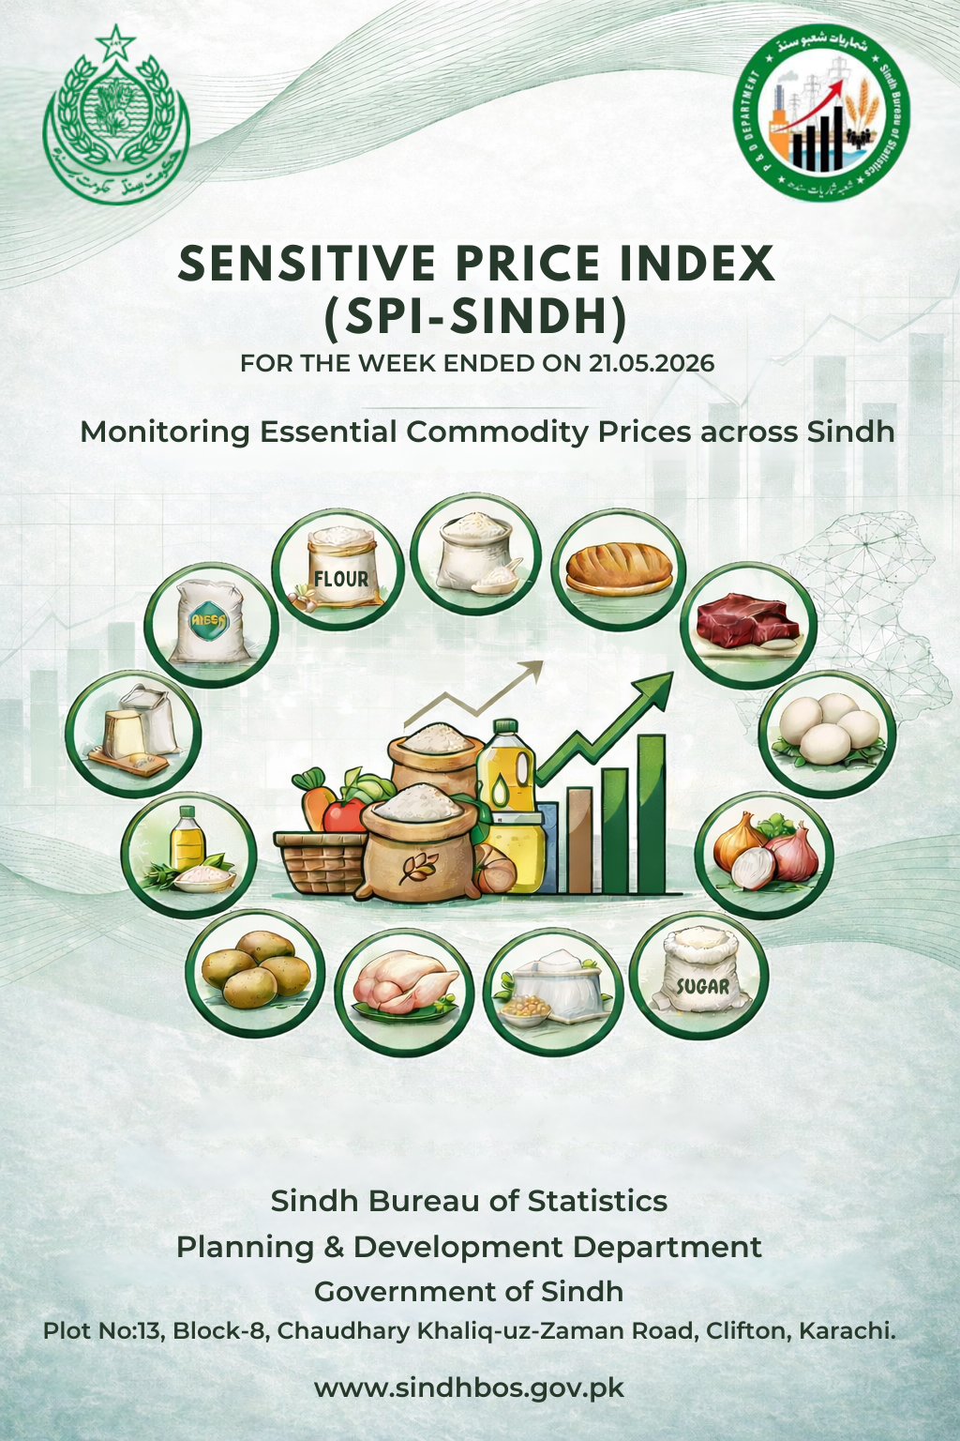

SENSITIVE PRICE INDEX SINDH
(SPI-Sindh)

FOR THE WEEK ENDED ON 21.05.2026

MONITORING ESSENTIAL COMMODITY PRICES ACROSS SINDH

-------------------------------------------------------
Contact us:
SPI Analysis Team
Economics & Price Statistics Section
Sindh Bureau of Statistics
pricestatistics.bos@gmail.com

-------------------------------------------------------



GOVERNMENT OF SINDH
PLANNING & DEVELOPMENT DEPARTMENT
SINDH BUREAU OF STATISTICS
Karachi Dated: 21.05.2026

EXECUTIVE SUMMARY

SENSITIVE PRICE INDEX SINDH (SPI-Sindh) FOR THE WEEK ENDED ON 21.05.2026

Sensitive Price Index of Sindh (SPI-Sindh) has been calculated on a weekly basis to observe the price changes of 50 essential items in Sindh. SPI-Sindh is based on 50 essential items and prices collected from 120 Shops, 60 markets in 30 districts of Sindh (4 shops & 2 markets per district). The prices of Electricity & Gas are obtained from PBS’s SPI report for the same period. The Week on Week (WoW) and Month on Month (MoM) changes in SPI-Sindh are as follows:

Period | 23.04.2026 | 14.05.2026 | 21.05.2026 | %Change Over
 |  |  |  | 14.05.2026 (WoW) | 23.04.2026 (MoM)
SPI-Sindh | 361.78 | 368.05 | 365.29 | -0.75% | 0.97%

As validation strategy, the SPI of Sindh has been cross-checked against PBS price data of four major cities (Karachi, Hyderabad, Sukkur, and Larkana) of Sindh disseminated under National SPI by PBS for the same week ended on 21.05.2026 wherein trend remained comparable and consistent. The SPI for Sindh calculated by SBOS on PBS’s price data of 4 major cities of Sindh disseminated under National SPI for the week ended on 21.05.2026 is provided hereunder for comparison:

Period | 30.04.2026 | 07.05.2026 | 14.05.2026 | 21.05.2026
SPI based on PBS Data  (4 Major Cities of Sindh) | 373.01 | 376.07 | 378.17 | 375.32
WoW % Change | 0.75 | 0.82 | 0.56 | -0.75

ANALYSIS OF SPI-SINDH:

SPI-Sindh for the current week as on 21.05.2026 decreased by -0.75 percent compared with the previous week, while on a month-on-month (MoM) basis, the index showed an overall increase of 0.97 percent, indicating continued inflationary pressure over the longer period despite weekly relief in selected commodities.
During the current week, an increase was registered in 20 commodities out of the basket of 50 essential items. The major increase was recorded in Tomatoes (14.5%), followed by Onions (3.6%), and Wheat Flour, Bag Average Quality (2.9%), Pulse Masoor, Washed and Long Cloth (1.6%) each, Chappal Sponge Bata Gents and Energy Saver (14 watts) (1.3%) each and Sandal Bata Ladies (1.2%) and Sandal Bata (Gents) (1.0%). The moderate increase was seen in Shirting, and Lawn (0.9%) each, Vegetable Ghee (Loose), Pulse Gram, Washed and Soap (Lifebuoy) (0.8%) each, Beef with Bone, Average Quality and Vegetable Ghee, Tin (0.7%) each and Cooking Oil, Tin (0.6%). The smallest increase was observed in Pulse Moong, Washed (0.5%), Tea Lipton Yellow Label Packet (0.2%), and Firewood Whole (0.2%).
On the other hand, a decrease was observed in 15 commodities, with the major decrease recorded in Electricity Charges, Upto 50 Units (-6.1%), followed by Garlic (-5.2%), Chicken Farm, Broiler, Live (-2.8%), Red Chili Powder, Loose (-1.5%), Petrol, Super and Hi-Speed Diesel (HSP) (-1.2%) each. Moderate declines were also observed in Curd (Dahi) and LPG Cylinder, 11kg (-1.1%) each and Washing Soap, 200-250 g (-1.0%), while smaller decreases were recorded in Pulse Mash, Washed, Rice Basmati Broker and Gur, Average Quality (-0.5%) each, Eggs Hen, Farm and Mustard Oil, Average Quality (-0.4%) each, and Georgette (-0.3%).
The prices of 15 commodities remained unchanged, including Bread Plain, Medium Size, Rice Irri (Punjab/Sindh), Mutton, Average Quality, Milk, Fresh, Unboiled, Powdered Milk, Nido, Polybag, Bananas, Potatoes, Sugar, Refined, Salt Powder, Loose, Lahori, Cooked Beef, Average Hotel, Cooked Daal, Average Hotel, Tea Prepared, Average Hotel, Cigarettes, K-2/Capstan,20's, Gas Charges, Up to 3.3719 MMBTU, and Match Box, Regular.
The weekly trend reflects relief in fuel, electricity, and selected food commodity prices during the week, contributing to the overall decline in the index. However, the MoM indicators suggest that inflationary pressure persists across major consumption categories in Sindh, particularly in cereals, fruits, vegetables, and prepared food items.
*****
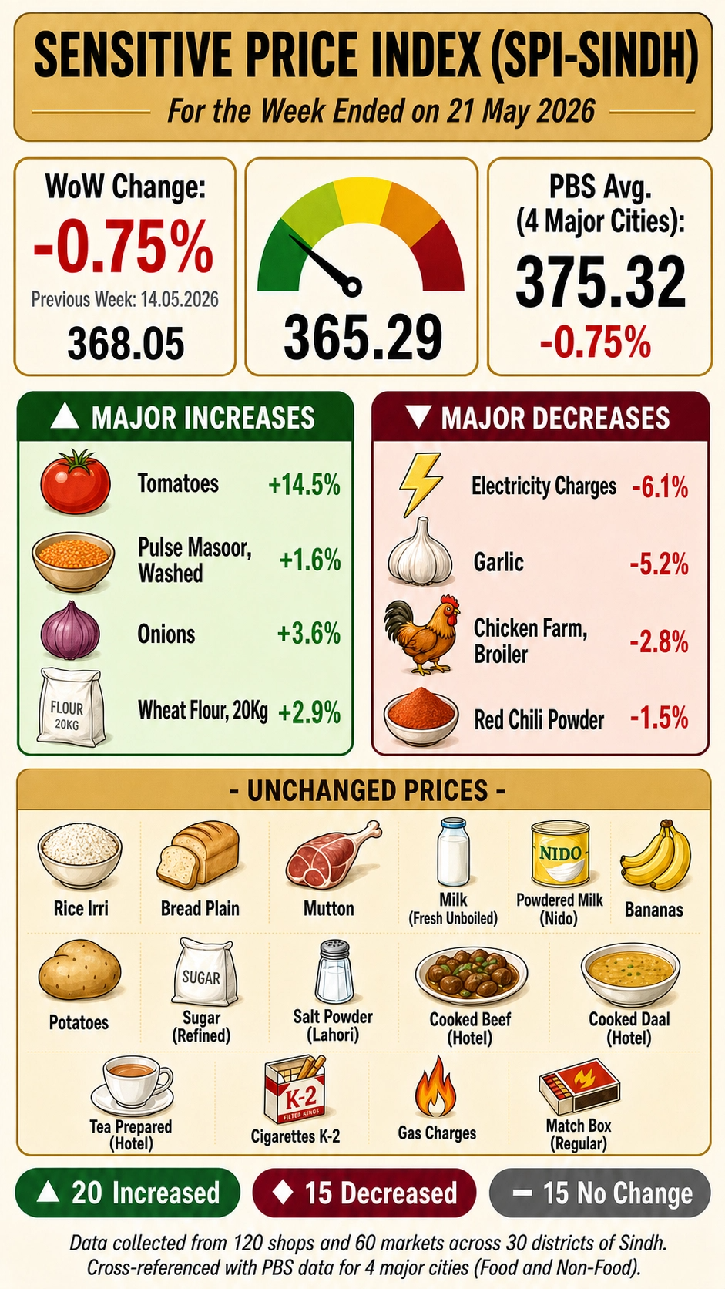
PART-II (SPI REPORT)
CATEGORY-WISE WEEKLY PRICE MOVEMENT IN SPI-SINDH (21.05.2026 OVER 14.05.2026)
The category-wise analysis of the Sensitive Price Index (SPI-Sindh) for the week ended on 21st May 2026 indicates an overall decrease of -0.75 percent compared to the previous week. The decline in the index was primarily driven by a notable decrease in Fuel & Energy (-2.17%), followed by Spices & Condiments (-1.10%), Meat & Protein (-0.64%), and Dairy (-0.09%), reflecting downward pressure in selected food and energy-related categories during the week.
On the other hand, significant increases were observed in Vegetables (3.11%), Clothing & Footwear (1.12%), Cereals & Bakery (1.90%), and Pulses & Legumes (1.11%), indicating upward movement in major consumption groups. Moderate increases were also recorded in Oils & Fats (0.71%) and Tea (0.14%) during the period.
Meanwhile, Fruits, Sugar & Sweeteners, Prepared Food, Tobacco, and Household Supplies remained stable with no change (0.00%) during the week. The detailed list of commodities included under each category is provided at Annex-A for reference.
Table 1: SPI-SINDH Week on Week (WoW) Percentage Changes (21.05.2026 OVER 14.05.2026)
S. No. | Category | Items Count |  | WoW Change %
1 | Cereals & Bakery | 4 |  | 1.90
2 | Meat & Protein | 4 |  | -0.64
3 | Dairy | 3 |  | -0.09
4 | Oils & Fats | 4 |  | 0.71
5 | Vegetables | 4 |  | 3.11
6 | Fruits | 1 |  | 0.00
7 | Pulses & Legumes | 4 |  | 1.11
8 | Sugar & Sweeteners | 2 |  | 0.00
9 | Spices & Condiments | 2 |  | -1.10
10 | Tea | 2 |  | 0.14
11 | Prepared Food | 2 |  | 0.00
12 | Tobacco | 1 |  | 0.00
13 | Clothing & Footwear | 7 |  | 1.12
14 | Fuel & Energy | 6 |  | -2.17
15 | Household Supplies | 4 |  | 0.00
 | Total | 50 |  | -0.75

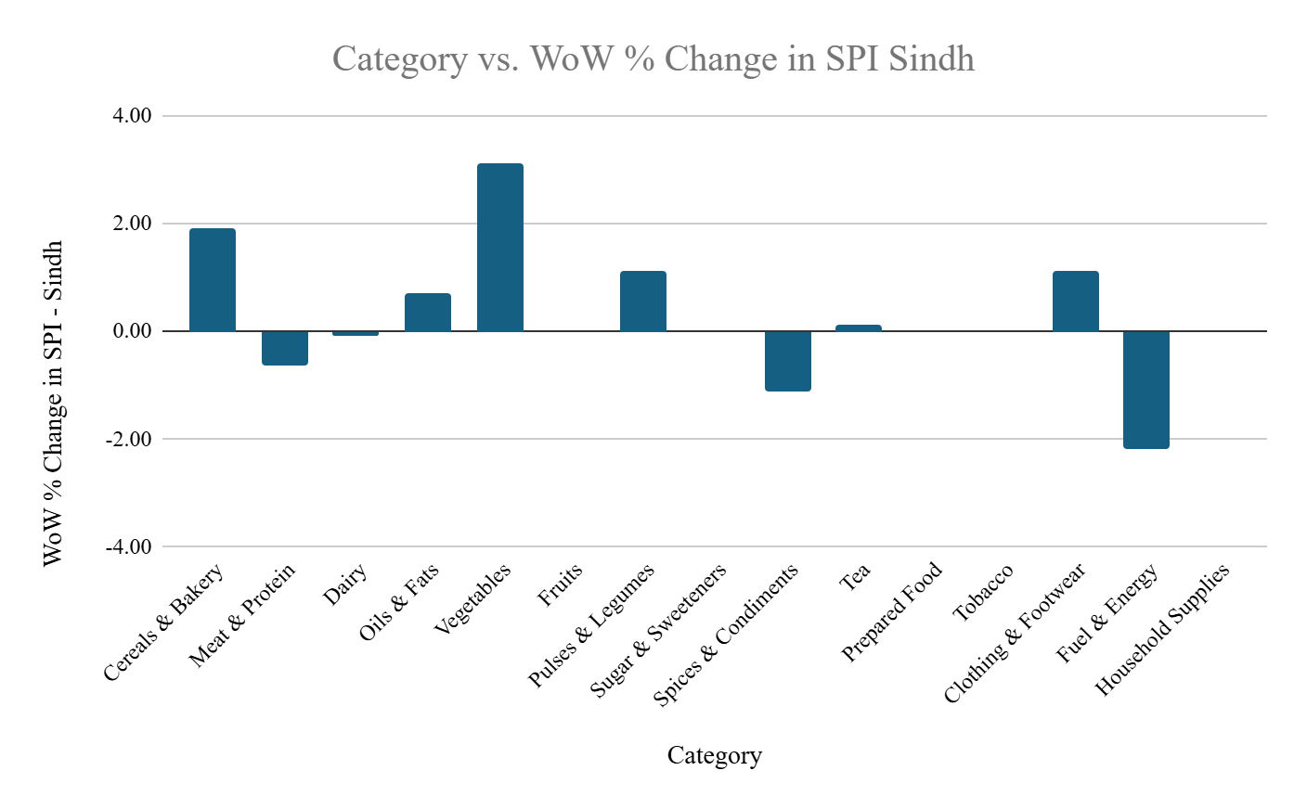

COMPARISON CURRENT WEEK OVER LAST WEEK (21.05.2026 OVER 14.05.2026)

The following table presents the percentage changes in prices of commodities included in the SPI basket between the 3rd week of May 2026 and 2nd week of May ended on 21st May 2026.
Table 2 : COMPARISON CURRENT WEEK OVER LAST WEEK (21.05.2026 OVER 14.05.2026)
S. No. | Commodities | Average Prices of All Districts in Sindh |  |  | Percentage Change (%)
S. No. | Commodities | Week Ended On |  |  | Percentage Change (%)
S. No. | Commodities | Unit | 14.05.2026 | 21.05.2026 | Percentage Change (%)
Average Prices of 20 items Registered Increase
1 | Tomatoes | 1 kg | 62 | 71 | 14.5
2 | Onions | 1 kg | 56 | 58 | 3.6
3 | Wheat Flour, Bag Average Quality | 20 kg | 2324 | 2392 | 2.9
4 | Pulse Masoor, Washed | 1 kg | 253 | 257 | 1.6
5 | Long Cloth | 1 mtr | 516 | 524 | 1.6
6 | Chappal Sponge Bata (Gents) | Pair | 900 | 912 | 1.3
7 | Energy Saver (14 watts) | Each | 236 | 239 | 1.3
8 | Sandal Bata (Ladies) | Pair | 1844 | 1867 | 1.2
9 | Sandal Bata (Gents) | Pair | 2452 | 2476 | 1.0
10 | Shirting | 1 mtr | 437 | 441 | 0.9
11 | Lawn | 1 mtr | 451 | 455 | 0.9
12 | Vegetable Ghee (Loose) | 1 kg | 503 | 507 | 0.8
13 | Pulse Gram, Washed | 1 kg | 265 | 267 | 0.8
14 | Soap, Lifebuoy | Each | 120 | 121 | 0.8
15 | Beef with Bone, Average quality | 1 kg | 1241 | 1250 | 0.7
16 | Vegetable Ghee, Tin, Specify Name | 2.5 kg | 1418 | 1428 | 0.7
17 | Cooking Oil, Tin, Specify Name | 2.5 Ltr | 1432 | 1440 | 0.6
18 | Pulse Moong, Washed | 1 kg | 379 | 381 | 0.5
19 | Tea, Lipton Yellow Label, Packet | 200 gm | 409 | 410 | 0.2
20 | Firewood Whole | 40 kg | 953 | 955 | 0.2
Average Prices of 15 items Registered No Change
1 | Rice Irri (Punjab/Sindh) | 1 kg | 132 | 132 | 0.0
2 | Bread Plain, Medium Size | Each | 122 | 122 | 0.0
3 | Mutton, Average Quality | 1 kg | 2194 | 2193 | 0.0
4 | Milk, Fresh, Unboiled | 1 Ltr | 220 | 220 | 0.0
5 | Powdered Milk, Nido, Polybag | 400 gm | 1159 | 1159 | 0.0
6 | Bananas | Dozen | 148 | 148 | 0.0
7 | Potatoes | 1 kg | 34 | 34 | 0.0
8 | Sugar, Refined | 1 kg | 146 | 146 | 0.0
9 | Salt Powder, Loose, Lahori | 1 kg | 32 | 32 | 0.0
10 | Cooked Beef, Average Hotel | Plate | 275 | 275 | 0.0
11 | Cooked Daal, Average Hotel | Plate | 166 | 166 | 0.0
12 | Tea Prepared, Average Hotel | Cup | 75 | 75 | 0.0
13 | Cigarettes, K-2/Capstan,20's | Packet | 255 | 255 | 0.0
14 | Gas Charges, Upto 3.3719 MMBTU | MMBTU | 2567 | 2567 | 0.0
15 | Match Box, Regular | Each | 6 | 6 | 0.0
Average Prices of 15 items Registered Decrease
1 | Electricity Charges, Upto 50 Units | Unit | 7.40 | 6.95 | -6.1
2 | Garlic | 1 kg | 381 | 361 | -5.2
3 | Chicken Farm, Broiler, Live | 1 kg | 424 | 412 | -2.8
4 | Red Chili Powder, Loose | 1 kg | 668 | 658 | -1.5
5 | Petrol, Super | 1 Ltr | 417 | 412 | -1.2
6 | Hi Speed Diesel (HSP) | 1 Ltr | 417 | 412 | -1.2
7 | Curd (Dahi) | 1 kg | 284 | 281 | -1.1
8 | LPG Cylinder, 11kg | Each | 4428 | 4380 | -1.1
9 | Washing Soap, 200-250 g, Specify Name | Cake | 105 | 104 | -1.0
10 | Rice Basmati Broken, Average Quality | 1 kg | 196 | 195 | -0.5
11 | Pulse Mash, Washed | 1 kg | 431 | 429 | -0.5
12 | Gur, Average Quality | 1 kg | 203 | 202 | -0.5
13 | Eggs Hen, Farm | Dozen | 230 | 229 | -0.4
14 | Mustard Oil, Average Quality | 1 kg | 526 | 524 | -0.4
15 | Georgette | 1 mtr | 321 | 320 | -0.3

CATEGORY-WISE DIVISION LEVEL ANALYSIS (WoW)
The division-wise analysis of SPI-Sindh reveals mixed price movements across regions during the week ended on 21st May 2026. The data highlights varying regional inflationary patterns across Karachi, Hyderabad, Sukkur, Larkana, Mirpurkhas, and Shaheed Benazirabad, reflecting differences in local supply conditions, transportation costs, seasonal availability, and market dynamics. At the provincial level, Sindh recorded a weekly decrease of -0.75 percent, mainly driven by declines in Fuel & Energy, Meat & Protein, and Spices & Condiments, despite notable increases in selected food and consumer categories.

Karachi exhibited relatively moderate price movements during the week. Significant increases were observed in Fruits (2.6%), Tea (1.9%), Clothing & Footwear (1.3%) and Household Supplies (0.9%),, while Cereals & Bakery recorded a mild increase of (0.4%.) On the other hand, the city experienced declines in Spices & Condiments (-5.6%), Fuel & Energy (-2.0%), and Meat & Protein (-1.9%), indicating easing pressure in selected household consumption groups.
Hyderabad Division showed strong inflationary pressure in fresh food commodities. Vegetables increased sharply by 5.6%, while Fruits recorded a substantial rise of 11.1%, representing one of the highest increases among all divisions. Moderate increases were also observed in Spices & Condiments (4.1%), Meat & Protein (2.2%), and Oils & Fats (1.8%). However, Sugar & Sweeteners (-2.0%) and Tobacco (-0.7%) registered declines during the week.
Sukkur presented highly volatile price behavior with mixed commodity trends. Where a small decline of (-0.5) was observed in Cereals & Bakery along with significant declined in Vegetables (-7.7%) and Fruits (-12.2%), the division simultaneously recorded increases in Spices & Condiments (3.7%), Sugar & Sweeteners (2.0%) Tobacco (1.2%) and Oils & Fats (0.1%). Fuel & Energy also declined by (-2.0%), indicating relief in energy-related items during the period.
Larkana demonstrated a moderate upward pressure in selected food and Non-food categories, where Vegetables, increased by (7.5%), Clothing & Footwear (1.6%), Sugar & Sweeteners (1.4%), and Cereals & Bakery (0.4%). Conversely, declines were observed in Fruits (-4.3%), Fuel & Energy (-2.1%), Dairy (-1.2%), and Meat & Protein (-0.8%).
Mirpurkhas displayed comparatively stable trends in several categories, with no change recorded in Dairy, Oils & Fats, Fruits, Pulses & Legumes, Tea, Prepared Food, Tobacco, Clothing & Footwear and Household Supplies. However, the division recorded an increase in Cereals & Bakery (2.5%) and Sugar & Sweeteners (2.4%), indicating localized supply-side pressure. Meat & Protein declined significantly by (-3.3%), while Fuel & Energy fell by (-1.7%).
Shaheed Benazirabad experienced substantial volatility during the week. Vegetables increased sharply by (10.1%), while Prepared Food rose notably by 3.2%, reflecting pressure in food-related consumption categories. On the other hand, Fruits declined sharply by -13.9%, representing the highest decrease among all divisions. Additional declines were observed in Spices & Condiments (-4.7%), Meat & Protein (-2.8%), and Fuel & Energy (-1.3%).

At the provincial level, Vegetables recorded the highest increase in Sindh (3.1%), followed by Pulses & Legumes (1.1%). Meanwhile, Fuel & Energy (-1.5%), Spices & Condiments (-0.8%), Meat & Protein (-0.7%), and Dairy (-0.3%) exerted downward pressure on the overall index. Several categories including Fruits, Sugar & Sweeteners, Prepared Food and Tobacco remained relatively stable at the provincial level. Overall, the division-wise analysis indicates a mixed inflationary environment in Sindh, characterized by sharp regional fluctuations in perishable food commodities alongside declines in fuel and selected household consumption groups.
Table 3: Category-wise Division Level WoW Price Changes in percentage (21.05.2026 OVER 14.05.2026)
S.No. | Category | Items Count | Karachi | Hyderabad | Sukkur | Larkana | Mirpurkhas | Sh. Benazirabad | Sindh
1 | Cereals & Bakery | 4 | 0.4 | 0.9 | -0.5 | 0.4 | 2.5 | -0.4 | 0.6
2 | Meat & Protein | 4 | -1.9 | 2.2 | -2.0 | -0.8 | -3.3 | -2.8 | -0.7
3 | Dairy | 3 | -0.2 | -0.1 | 0.0 | -1.2 | 0.0 | -0.6 | -0.3
4 | Oils & Fats | 4 | -0.1 | 1.8 | 0.1 | -0.5 | 0.0 | -0.7 | 0.6
5 | Vegetables | 4 | 0.6 | 5.6 | -7.7 | 7.5 | -1.6 | 10.1 | 3.1
6 | Fruits | 1 | 2.6 | 11.1 | -12.2 | -4.3 | 0.0 | -13.9 | 0.0
7 | Pulses & Legumes | 4 | 0.2 | 1.6 | -1.1 | 0.4 | 0.0 | 0.9 | 1.1
8 | Sugar & Sweeteners | 2 | -0.5 | -2.0 | 2.0 | 1.4 | 2.4 | -2.1 | 0.0
9 | Spices & Condiments | 2 | -5.6 | 4.1 | 3.7 | -0.7 | -0.5 | -4.7 | -0.8
10 | Tea | 2 | 1.9 | -0.1 | 0.0 | -0.9 | 0.0 | 0.7 | 0.2
11 | Prepared Food | 2 | -0.8 | 0.7 | 0.0 | 0.0 | 0.0 | 3.2 | 0.0
12 | Tobacco | 1 | 0.4 | -0.7 | 1.2 | 0.1 | 0.0 | 0.0 | 0.0
13 | Clothing & Footwear | 7 | 1.3 | 1.3 | -0.2 | 1.6 | 0.0 | 0.6 | 0.9
14 | Fuel & Energy | 6 | -2.0 | -0.8 | -2.0 | -2.1 | -1.7 | -1.3 | -1.5
15 | Household Supplies | 4 | 0.9 | 0.3 | -0.3 | 0.0 | 0.0 | 1.6 | 0.4
Green = Decrease | Grey = No Change | Orange/Red = Increase (Color intensity increases with magnitude of change)
Values represent weighted simple averages of commodity-level week-on-week (%) changes within each category.
The Sindh column represents the provincial average.

CATEGORY-WISE MONTHLY PRICE MOVEMENT IN SPI-SINDH (21.05.2026 OVER 23.04.2026)
The category-wise analysis of the Sensitive Price Index (SPI-Sindh) for the period ending on 21st May 2026 indicates an overall increase of 0.97 percent compared to 23rd April 2026. The rise in the index was primarily driven by substantial increases in Fruits (12.25%), Cereals & Bakery (10.01%), and Vegetables (4.29%), reflecting strong upward pressure across major food consumption groups during the period.
Further notable increases were observed in Prepared Food (2.61%), Fuel & Energy (0.31%), and Oils & Fats (1.90%), indicating continued inflationary movement in both food and non-food categories. Additional increases were also recorded in Clothing & Footwear (1.12%), Tobacco (1.47%), Household Supplies (1.02%), and Spices & Condiments (0.75%). A marginal increase was observed in Dairy (0.04%) during the period.
On the other hand, slight declines were recorded in Tea (-0.63%), Sugar & Sweeteners (-0.13%), and Meat & Protein (-0.06%), indicating minor relief in selected consumption groups.
Meanwhile, Pulses & Legumes remained stable during the period with no change (0.00%). The detailed list of commodities included under each category is provided at Annex-A for reference.
Table 4: SPI-SINDH Month on Month (MoM) Percentage Changes (21.05.2026 OVER 23.04.2026)
S. No. | Category | Items Count | MoM % Change
1 | Cereals & Bakery | 4 | 10.01
2 | Meat & Protein | 4 | -0.06
3 | Dairy | 3 | 0.04
4 | Oils & Fats | 4 | 1.90
5 | Vegetables | 4 | 4.29
6 | Fruits | 1 | 12.25
7 | Pulses & Legumes | 4 | 0.00
8 | Sugar & Sweeteners | 2 | -0.13
9 | Spices & Condiments | 2 | 0.75
10 | Tea | 2 | -0.63
11 | Prepared Food | 2 | 2.61
12 | Tobacco | 1 | 1.47
13 | Clothing & Footwear | 7 | 1.12
14 | Fuel & Energy | 6 | 0.31
15 | Household Supplies | 4 | 1.02
 | Total | 50 | 0.97
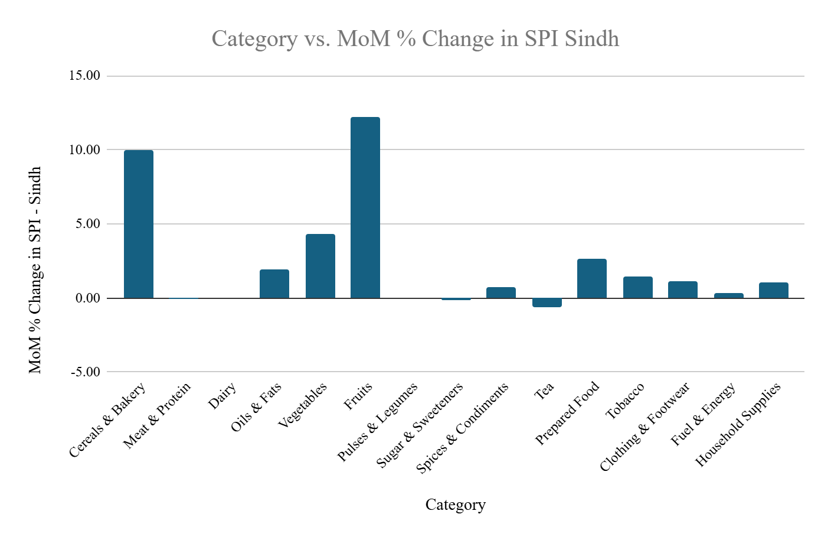
MONTH ON MONTH (MOM) COMPARISON CURRENT WEEK OVER THE CORRESPONDING WEEK (21.05.2026 OVER 23.04.2026)

The following table presents the Month on Month (MoM) percentage changes in prices of commodities included in the SPI basket between the 3rd week of May 2026 and 4th week of April.
Table 5: COMPARISON CURRENT MONTH OVER LAST MONTH (21.05.2026 OVER 23.04.2026)
S. No. | Commodities | Average Prices of All Districts in Sindh |  |  | Percentage Change (%)
S. No. | Commodities | Week Ended On |  |  | Percentage Change (%)
S. No. | Commodities | Unit | 21.05.2026 | 23.04.2026 | Percentage Change (%)
Average Prices of 29 items Registered Increase
1 | Hi Speed Diesel (HSP) | 1 Ltr | 412 | 356 | 15.73
2 | Wheat Flour, Bag | 20 kg | 2392 | 2110 | 13.36
3 | Tomatoes | 1 kg | 71 | 63 | 12.70
4 | Bananas | Dozen | 148 | 132 | 12.12
5 | Petrol, Super | 1 Ltr | 412 | 369 | 11.65
6 | Onions | 1 kg | 58 | 52 | 11.54
7 | Rice Basmati Broken, Average Quality | 1 kg | 195 | 186 | 4.84
8 | Sandal Bata (Ladies) | Pair | 1867 | 1787 | 4.48
9 | Cooked Beef, Average Hotel | Plate | 275 | 266 | 3.38
10 | Georgette | 1 mtr | 320 | 310 | 3.23
11 | Sandal Bata (Gents) | Pair | 2476 | 2400 | 3.17
12 | Potatoes | 1 kg | 34 | 33 | 3.0
13 | Vegetable Ghee (Loose) | 1 kg | 507 | 497 | 2.0
14 | Vegetable Ghee, Tin, Specify Name | 2.5 kg | 1428 | 1400 | 2.0
15 | Washing Soap, 200-250 g, Specify Name | Cake | 104 | 102 | 2.0
16 | Powdered Milk, Nido, Polybag | 400 gm | 1159 | 1138 | 1.8
17 | Cooked Daal, Average Hotel | Plate | 166 | 163 | 1.8
18 | Cooking Oil, Tin, Specify Name | 2.5 Ltr | 1440 | 1415 | 1.8
19 | Bread Plain, Medium Size | Each | 122 | 120 | 1.7
20 | Cigarettes, K-2/Capstan, 20's | Packet | 255 | 251 | 1.6
21 | Red Chili Powder, Loose | 1 kg | 658 | 649 | 1.4
22 | Energy Saver (14 watts) | Each | 239 | 236 | 1.3
23 | Mutton, Average Quality | 1 kg | 2193 | 2166 | 1.2
24 | Beef with Bone, Average quality | 1 kg | 1250 | 1236 | 1.13
25 | Chicken Farm, Broiler, Live | 1 kg | 412 | 409 | 0.73
26 | Chappal Sponge Bata (Gents) | Pair | 912 | 908 | 0.44
27 | Pulse Moong, Washed | 1 kg | 381 | 380 | 0.26
28 | Tea, Lipton Yellow Label, Packet | 200 gm | 410 | 409 | 0.24
29 | Pulse Mash, Washed | 1 kg | 429 | 428 | 0.23
Average Prices of 09 items Registered No Change
1 | Rice Irri (Punjab/Sindh) | 1 kg | 132 | 132 | 0.0
2 | Milk, Fresh, Unboiled | 1 Ltr | 220 | 220 | 0.00
3 | Curd (Dahi) | 1 kg | 281 | 281 | 0.00
4 | Pulse Masoor, Washed | 1 kg | 257 | 257 | 0.00
5 | Sugar, Refined | 1 kg | 146 | 146 | 0.00
6 | Salt Powder, Loose, Lahori | 1 kg | 32 | 32 | 0.00
7 | Gas Charges, Upto 3.3719 MMBTU | MMBTU | 2567 | 2567 | 0.0
8 | Match Box, Regular | Each | 6 | 6 | 0.0
9 | Soap, Lifebuoy | Each | 121 | 121 | 0.0
Average Prices of 12 items Registered Decrease
1 | Garlic | 1 kg | 361 | 423 | -14.66
2 | Eggs Hen, Farm | Dozen | 229 | 250 | -8.40
3 | Electricity Charges, Upto 50 Units | Unit | 6.9 | 7.47 | -6.96
4 | LPG Cylinder, 11kg | Each | 4380 | 4565 | -4.05
5 | Firewood Whole | 40 kg | 955 | 974 | -1.95
6 | Gur, Average Quality | 1 kg | 202 | 206 | -1.94
7 | Shirting | 1 mtr | 441 | 448 | -1.56
8 | Tea Prepared, Average Hotel | Cup | 75 | 76 | -1.32
9 | Pulse Gram, Washed | 1 kg | 267 | 270 | -1.11
10 | Mustard Oil, Average Quality | 1 kg | 524 | 529 | -0.95
11 | Lawn | 1 mtr | 455 | 457 | -0.44
12 | Long Cloth | 1 mtr | 524 | 525 | -0.19

Annexure-A

S.No. | Categories | No. of Items | Commodity/items
1 | Cereals & Bakery | 4 | Wheat Flour
1 | Cereals & Bakery | 4 | Rice Basmati Broken
1 | Cereals & Bakery | 4 | Rice Irri
1 | Cereals & Bakery | 4 | Bread Plain
2 | Clothing & Footwear | 7 | Long Cloth
2 | Clothing & Footwear | 7 | Shirting
2 | Clothing & Footwear | 7 | Lawn
2 | Clothing & Footwear | 7 | Georgette
2 | Clothing & Footwear | 7 | Sandal Bata Gents
2 | Clothing & Footwear | 7 | Chappal Sponge Gents
2 | Clothing & Footwear | 7 | Sandal Bata Ladies
3 | Dairy | 3 | Milk Fresh
3 | Dairy | 3 | Curd (Dahi)
3 | Dairy | 3 | Powdered Milk Nido
4 | Fruits | 1 | Bananas
5 | Fuel & Energy | 6 | Electricity Charges
5 | Fuel & Energy | 6 | Gas Charges
5 | Fuel & Energy | 6 | Firewood
5 | Fuel & Energy | 6 | Petrol Super
5 | Fuel & Energy | 6 | Hi Speed Diesel
5 | Fuel & Energy | 6 | LPG Cylinder
6 | Household Supplies | 4 | Energy Saver
6 | Household Supplies | 4 | Washing Soap
6 | Household Supplies | 4 | Match Box
6 | Household Supplies | 4 | Soap Lifebuoy
7 | Meat & Protein | 4 | Beef with Bone
7 | Meat & Protein | 4 | Mutton
7 | Meat & Protein | 4 | Chicken Farm
7 | Meat & Protein | 4 | Eggs Hen Farm
8 | Oils & Fats | 4 | Mustard Oil
8 | Oils & Fats | 4 | Cooking Oil Tin
8 | Oils & Fats | 4 | Vegetable Ghee Tin
8 | Oils & Fats | 4 | Vegetable Ghee Loose
9 | Prepared Food | 2 | Cooked Beef Hotel
9 | Prepared Food | 2 | Cooked Daal Hotel
10 | Pulses & Legumes | 4 | Pulse Masoor
10 | Pulses & Legumes | 4 | Pulse Moong
10 | Pulses & Legumes | 4 | Pulse Mash
10 | Pulses & Legumes | 4 | Pulse Gram
11 | Spices & Condiments | 2 | Salt Powder
11 | Spices & Condiments | 2 | Red Chili Powder
12 | Sugar & Sweeteners | 2 | Sugar Refined
12 | Sugar & Sweeteners | 2 | Gur
13 | Tea | 2 | Tea Lipton
13 | Tea | 2 | Tea Prepared Hotel
14 | Tobacco | 1 | Cigarettes K-2/Capstan
15 | Vegetables | 4 | Potatoes
15 | Vegetables | 4 | Onions
15 | Vegetables | 4 | Tomatoes
15 | Vegetables | 4 | Garlic

Annexure-B
Average Prices of 50 Essential Commodities in 30 Districts of Sindh as on 21st May 2026

S No. | Description | Unit | Karachi South | Karachi West | Karachi East | Karachi Central | Korangi | Keamari | Malir
1 | Wheat Flour, Bag Average Quality | 20 kg | 2474 | 2600 | 2468 | 2525 | 2350 | 2280 | 2487
2 | Rice Basmati Broken, Average Quality | 1 kg | 209 | 270 | 192 | 230 | 247 | 222 | 257
3 | Rice Irri (Punjab/Sindh) | 1 kg | 152 | 197 | 120 | 205 | 132 | 177 | 147
4 | Bread Plain, Medium Size | Each | 114 | 120 | 130 | 130 | 82 | 105 | 110
5 | Beef with Bone, Average quality | 1 kg | 1457 | 1600 | 1324 | 1524 | 1000 | 1474 | 1300
6 | Mutton, Average Quality | 1 kg | 2550 | 2600 | 2425 | 2525 | 2000 | 2700 | 2400
7 | Chicken Farm, Broiler, Live | 1 kg | 436 | 405 | 467 | 455 | 410 | 402 | 390
8 | Milk, Fresh, Unboiled | 1 Ltr | 240 | 240 | 240 | 240 | 240 | 240 | 240
9 | Curd (Dahi) | 1 kg | 360 | 347 | 360 | 360 | 360 | 360 | 360
10 | Powdered Milk, Nido, Polybag | 400 gm | 1167 | 1150 | 1132 | 1185 | 1080 | 1200 | 1087
11 | Eggs Hen, Farm | Dozen | 204 | 227 | 260 | 240 | 242 | 280 | 242
12 | Mustard Oil, Average Quality | 1 kg | 559 | 527 | 600 | 574 | 457 | 600 | 502
13 | Cooking Oil, Tin | 2.5 Ltr | 1459 | 1525 | 1480 | 1475 | 1150 | 1550 | 1449
14 | Vegetable Ghee, Tin | 2.5 kg | 1500 | 1537 | 1475 | 1500 | 1500 | 1520 | 1500
15 | Vegetable Ghee (Loose) | 1 kg | 524 | 547 | 575 | 545 | 537 | 500 | 524
16 | Bananas | Dozen | 197 | 182 | 142 | 211 | 122 | 150 | 150
17 | Pulse Masoor, Washed | 1 kg | 241 | 320 | 242 | 247 | 205 | 245 | 240
18 | Pulse Moong, Washed | 1 kg | 400 | 400 | 382 | 400 | 295 | 355 | 341
19 | Pulse Mash, Washed | 1 kg | 405 | 450 | 445 | 430 | 415 | 435 | 415
20 | Pulse Gram, Washed | 1 kg | 247 | 325 | 240 | 250 | 210 | 242 | 235
21 | Potatoes | 1 kg | 42 | 47 | 52 | 45 | 50 | 50 | 52
22 | Onions | 1 kg | 77 | 55 | 75 | 76 | 80 | 50 | 80
23 | Tomatoes | 1 kg | 99 | 65 | 85 | 72 | 100 | 85 | 80
24 | Sugar, Refined | 1 kg | 146 | 150 | 150 | 150 | 145 | 147 | 145
25 | Gur, Average Quality | 1 kg | 240 | 265 | 245 | 245 | 237 | 230 | 214
26 | Salt Powder, Loose, Lahori | 1 kg | 50 | 35 | 62 | 60 | 36 | 30 | 37
27 | Red Chili Powder, Loose | 1 kg | 818 | 849 | 800 | 849 | 524 | 612 | 524
28 | Garlic | 1 kg | 468 | 400 | 387 | 346 | 362 | 300 | 431
29 | Tea, Lipton Yellow Label, Packet | 200 gm | 395 | 400 | 397 | 397 | 395 | 400 | 395
30 | Cooked Beef, Average Hotel | Plate | 224 | 247 | 345 | 374 | 315 | 324 | 300
31 | Cooked Daal, Average Hotel | Plate | 140 | 155 | 207 | 175 | 199 | 150 | 190
32 | Tea Prepared, Average Hotel | Cup | 70 | 70 | 80 | 80 | 80 | 75 | 75
33 | Cigarettes, K-2/Capstan,20's | Packet | 252 | 240 | 257 | 260 | 260 | 260 | 252
34 | Long Cloth | 1 mtr | 812 | 800 | 624 | 850 | 574 | 650 | 775
35 | Shirting | 1 mtr | 398 | 648 | 599 | 700 | 424 | 450 | 462
36 | Lawn | 1 mtr | 749 | 592 | 636 | 762 | 524 | 400 | 675
37 | Georgette | 1 mtr | 335 | 600 | 424 | 300 | 574 | 324 | 423
38 | Sandal Bata (Gents) | Pair | 2958 | 1999 | 2424 | 3475 | 2500 | 3499 | 2499
39 | Chappal Sponge Bata (Gents) | Pair | 912 | 1499 | 699 | 1174 | 600 | 699 | 700
40 | Sandal Bata (Ladies) | Pair | 2236 | 3200 | 2030 | 2500 | 2000 | 3300 | 2000
41 | Electricity Charges, Upto 50 Units | Unit | 6.95 | 6.95 | 6.95 | 6.95 | 6.95 | 6.95 | 6.95
42 | Gas Charges, Upto 3.3719 MMBTU | MMBTU | 2566.5 | 2566.5 | 2566.5 | 2566.5 | 2566.5 | 2566.5 | 2566.5
43 | Firewood Whole | 40 kg | 1400 | 1549 | .. | 1600 | 1200 | 1200 | 1249
44 | Energy Saver (14 watts) | Each | 245 | 250 | 185 | 232 | 170 | 300 | 182
45 | Washing Soap, 200-250 g, Specify Name | Cake | 112 | 155 | 140 | 95 | 80 | 100 | 121
46 | Match Box, Regular | Each | 5 | 6 | 7 | 8 | 7 | 7 | 7
47 | Petrol, Super | 1 Ltr | 411 | 411 | 412 | 410 | 411 | 410 | 411
48 | Hi Speed Diesel (HSP) | 1 Ltr | 411 | 411 | 411 | 410 | 410 | 410 | 410
49 | LPG Cylinder, 11kg | Each | 4070 | 4070 | 4125 | 4070 | 4180 | 4180 | 4070
50 | Soap, Lifebuoy | Each | 125 | 130 | 127 | 125 | 107 | 100 | 100
Note: (..) = Currently unavailable/Limited availability
Continued

S No. | Description | Unit | Hyderabad | Badin | Jamshoro | Tando. Allahyar | Tando Muhammad Khan | Thatta | Sujawal | Dadu | Matiari
1 | Wheat Flour, Bag Average Quality | 20 kg | 2520 | 2650 | 2345 | 2449 | 2200 | 2498 | 2424 | 2600 | 2380
2 | Rice Basmati Broken, Average Quality | 1 kg | 235 | 140 | 140 | 215 | 200 | 210 | 210 | 190 | 199
3 | Rice Irri (Punjab/Sindh) | 1 kg | 95 | 115 | 96 | 100 | 155 | 125 | 100 | 165 | 95
4 | Bread Plain, Medium Size | Each | 120 | 100 | 120 | 125 | 125 | 120 | 120 | 160 | 120
5 | Beef with Bone, Average Quality | 1 kg | 1300 | 1200 | 1300 | 1200 | 1300 | 1149 | 1149 | 1400 | 1300
6 | Mutton, Average Quality | 1 kg | 2474 | 2249 | 2249 | 2348 | 2200 | 1912 | 1949 | 2200 | 2500
7 | Chicken Farm, Broiler, Live | 1 kg | 450 | 465 | 385 | 358 | 460 | 445 | 425 | 420 | 455
8 | Milk, Fresh, Unboiled | 1 Ltr | 230 | 220 | 220 | 225 | 220 | 204 | 205 | 220 | 225
9 | Curd (Dahi) | 1 kg | 320 | 250 | 310 | 274 | 300 | 230 | 215 | 260 | 310
10 | Powdered Milk, Nido, Polybag | 400 gm | 1130 | 1150 | 1150 | 1220 | 1145 | 1175 | 1175 | 1150 | 1140
11 | Eggs Hen, Farm | Dozen | 260 | 190 | 219 | 201 | 230 | 210 | 210 | 300 | 250
12 | Mustard Oil, Average Quality | 1 kg | 475 | 675 | 510 | 482 | 597 | 675 | 710 | 500 | 480
13 | Cooking Oil, Tin | 2.5 Ltr | 1450 | 1275 | 1280 | 1439 | 1425 | 1552 | 1555 | 1350 | 1440
14 | Vegetable Ghee, Tin | 2.5 kg | 1420 | 1350 | 1420 | 1337 | 1380 | 1545 | 1460 | 1600 | 1420
15 | Vegetable Ghee (Loose) | 1 kg | 465 | 480 | 500 | 470 | 545 | 485 | 485 | 580 | 460
16 | Bananas | Dozen | 155 | 190 | 150 | 224 | 200 | 177 | 155 | 125 | 110
17 | Pulse Masoor, Washed | 1 kg | 225 | 290 | 210 | 237 | 280 | 245 | 275 | 320 | 225
18 | Pulse Moong, Washed | 1 kg | 355 | 390 | 350 | 370 | 380 | 385 | 385 | 420 | 360
19 | Pulse Mash, Washed | 1 kg | 475 | 475 | 420 | 407 | 400 | 440 | 485 | 410 | 445
20 | Pulse Gram, Washed | 1 kg | 230 | 290 | 320 | 220 | 285 | 252 | 275 | 355 | 230
21 | Potatoes | 1 kg | 37 | 22 | 25 | 40 | 30 | 30 | 45 | 20 | 40
22 | Onions | 1 kg | 51 | 45 | 50 | 40 | 50 | 55 | 55 | 70 | 47
23 | Tomatoes | 1 kg | 75 | 77 | 65 | 47 | 80 | 97 | 90 | 85 | 77
24 | Sugar, Refined | 1 kg | 140 | 150 | 145 | 142 | 150 | 145 | 152 | 150 | 145
25 | Gur, Average Quality | 1 kg | 185 | 210 | 175 | 177 | 220 | 185 | 222 | 200 | 190
26 | Salt Powder, Loose, Lahori | 1 kg | 30 | 30 | 20 | 62 | 40 | 35 | 35 | 30 | 20
27 | Red Chili Powder, Loose | 1 kg | 675 | 825 | 547 | 587 | 690 | 675 | 705 | 550 | 624
28 | Garlic | 1 kg | 317 | 200 | 330 | 219 | 474 | 389 | 385 | 450 | 379
29 | Tea, Lipton Yellow Label, Packet | 200 gm | 400 | 400 | 380 | 380 | 400 | 447 | 435 | 444 | 390
30 | Cooked Beef, Average Hotel | Plate | 340 | 200 | 235 | 350 | 300 | 306 | 345 | 250 | 250
31 | Cooked Daal, Average Hotel | Plate | 164 | 150 | 150 | 200 | 200 | 181 | 240 | 180 | 150
32 | Tea Prepared, Average Hotel | Cup | 72 | 65 | 75 | 67 | 75 | 70 | 75 | 62 | 75
33 | Cigarettes, K-2/Capstan, 20's | Packet | 250 | 255 | 242 | 250 | 250 | 257 | 260 | 250 | 250
34 | Long Cloth | 1 mtr | 610 | 360 | 550 | 355 | 612 | 345 | 395 | 450 | 610
35 | Shirting | 1 mtr | 400 | 374 | 474 | 424 | 648 | 455 | 440 | 500 | 490
36 | Lawn | 1 mtr | 400 | 424 | 374 | 350 | 400 | 465 | 400 | 350 | 390
37 | Georgette | 1 mtr | 280 | 346 | 260 | 382 | 300 | 252 | 270 | 400 | 290
38 | Sandal Bata (Gents) | Pair | 2999 | 1648 | 2999 | 2719 | 2799 | 2500 | 2500 | 2599 | 2999
39 | Chappal Sponge Bata (Gents) | Pair | 1199 | 1148 | 449 | 1158 | 999 | 700 | 1800 | 1081 | 449
40 | Sandal Bata (Ladies) | Pair | 1299 | 2248 | 2249 | 2095 | 2500 | 1400 | 2300 | 1793 | 1199
41 | Electricity Charges, Upto 50 Units | Unit | 6.95 | 6.95 | 6.95 | 6.95 | 6.95 | 6.95 | 6.95 | 6.95 | 6.95
42 | Gas Charges, Upto 3.3719 MMBTU | MMBTU | 2566.5 | 2566.5 | 2566.5 | 2566.5 | 2566.5 | 2566.5 | 2566.5 | 2566.5 | 2566.5
43 | Firewood Whole | 40 kg | 800 | 624 | 1050 | 800 | 850 | 712 | 855 | 1000 | 949
44 | Energy Saver (14 watts) | Each | 400 | 374 | 250 | 200 | 235 | 324 | 345 | 300 | 150
45 | Washing Soap, 200-250 g | Cake | 97 | 110 | 100 | 99 | 120 | 100 | 100 | 120 | 100
46 | Match Box, Regular | Each | 5 | 5 | 5 | 5 | 7 | 5 | 6 | 6 | 5
47 | Petrol, Super | 1 Ltr | 414 | 414 | 410 | 415 | 413 | 412 | 413 | 412 | 414
48 | Hi Speed Diesel (HSP) | 1 Ltr | 413 | 415 | 410 | 415 | 415 | 413 | 414 | 412 | 413
49 | LPG Cylinder, 11kg | Each | 4562 | 4950 | 4620 | 4400 | 4510 | 4345 | 4380 | 4500 | 4400
50 | Soap, Lifebuoy | Each | 125 | 110 | 125 | 127 | 132 | 130 | 132 | 120 | 130
Continued

S No. | Description | Unit | Larkana | Shikarpur | Jacobabad | Kambar @ Shahdadkot | Kashmore @ Kandhkot | Shaheed. Benazirabad | Sanghar | N.  Feroze
1 | Wheat Flour, Bag Average Quality | 20 kg | 2075 | 2449 | 2275 | 2275 | 2300 | 2225 | 2400 | 2050
2 | Rice Basmati Broken, Average Quality | 1 kg | 180 | 134 | 174 | 185 | 160 | 145 | 200 | 280
3 | Rice Irri (Punjab/Sindh) | 1 kg | 135 | 110 | 101 | 125 | 142 | 135 | 140 | 130
4 | Bread Plain, Medium Size | Each | 140 | 105 | 125 | 160 | 140 | 135 | 100 | 150
5 | Beef with Bone, Average Quality | 1 kg | 1249 | 1074 | 1200 | 1262 | 1225 | 1175 | 1300 | 1200
6 | Mutton, Average Quality | 1 kg | 2200 | 2098 | 2200 | 1949 | 2200 | 2212 | 2200 | 1900
7 | Chicken Farm, Broiler, Live | 1 kg | 455 | 370 | 380 | 445 | 450 | 375 | 378 | 420
8 | Milk, Fresh, Unboiled | 1 Ltr | 245 | 212 | 242 | 230 | 230 | 210 | 200 | 200
9 | Curd (Dahi) | 1 kg | 280 | 257 | 290 | 290 | 250 | 307 | 230 | 280
10 | Powdered Milk, Nido, Polybag | 400 gm | 1050 | 1170 | 1210 | 1175 | 1200 | 1240 | 1150 | 1120
11 | Eggs Hen, Farm | Dozen | 235 | 200 | 200 | 247 | 220 | 165 | 240 | 230
12 | Mustard Oil, Average Quality | 1 kg | 500 | 495 | 526 | 544 | 500 | 475 | 470 | 470
13 | Cooking Oil, Tin | 2.5 Ltr | 1350 | 1500 | 1600 | 1395 | 1612 | 1375 | 1350 | 1530
14 | Vegetable Ghee, Tin | 2.5 kg | 1100 | 1450 | 1498 | 1230 | 1550 | 1425 | 1350 | 1480
15 | Vegetable Ghee (Loose) | 1 kg | 425 | 520 | 490 | 490 | 545 | 475 | 500 | 500
16 | Bananas | Dozen | 125 | 128 | 150 | 164 | 137 | 89 | 122 | 150
17 | Pulse Masoor, Washed | 1 kg | 280 | 290 | 295 | 247 | 287 | 290 | 240 | 230
18 | Pulse Moong, Washed | 1 kg | 360 | 440 | 410 | 410 | 390 | 395 | 370 | 400
19 | Pulse Mash, Washed | 1 kg | 360 | 437 | 382 | 390 | 400 | 465 | 395 | 430
20 | Pulse Gram, Washed | 1 kg | 325 | 290 | 274 | 245 | 295 | 295 | 281 | 240
21 | Potatoes | 1 kg | 30 | 21 | 30 | 30 | 52 | 26 | 37 | 25
22 | Onions | 1 kg | 45 | 50 | 50 | 77 | 67 | 75 | 55 | 50
23 | Tomatoes | 1 kg | 40 | 45 | 50 | 57 | 67 | 75 | 80 | 70
24 | Sugar, Refined | 1 kg | 155 | 145 | 140 | 150 | 150 | 139 | 140 | 140
25 | Gur, Average Quality | 1 kg | 185 | 200 | 181 | 175 | 197 | 170 | 180 | 190
26 | Salt Powder, Loose, Lahori | 1 kg | 20 | 30 | 30 | 39 | 40 | 35 | 20 | 20
27 | Red Chili Powder, Loose | 1 kg | 550 | 580 | 500 | 574 | 562 | 624 | 600 | 800
28 | Garlic | 1 kg | 385 | 374 | 300 | 429 | 265 | 387 | 346 | 460
29 | Tea, Lipton Yellow Label, Packet | 200 gm | 420 | 400 | 461 | 380 | 400 | 397 | 400 | 447
30 | Cooked Beef, Average Hotel | Plate | 400 | 200 | 250 | 290 | 235 | 229 | 320 | 250
31 | Cooked Daal, Average Hotel | Plate | 190 | 127 | 150 | 170 | 150 | 195 | 180 | 230
32 | Tea Prepared, Average Hotel | Cup | 89 | 65 | 100 | 77 | 67 | 70 | 80 | 100
33 | Cigarettes, K-2/Capstan, 20's | Packet | 250 | 245 | 270 | 257 | 270 | 267 | 270 | 260
34 | Long Cloth | 1 mtr | 450 | 566 | 320 | 440 | 395 | 574 | 600 | 490
35 | Shirting | 1 mtr | 300 | 458 | 271 | 442 | 427 | 574 | 274 | 300
36 | Lawn | 1 mtr | 640 | 367 | 259 | 546 | 445 | 675 | 350 | 350
37 | Georgette | 1 mtr | 350 | 190 | 247 | 295 | 365 | 675 | 270 | 250
38 | Sandal Bata (Gents) | Pair | 2350 | 1499 | 2599 | 2500 | 1699 | 2568 | 2098 | 2670
39 | Chappal Sponge Bata (Gents) | Pair | 550 | 599 | 1448 | 700 | 1199 | 1549 | 700 | 800
40 | Sandal Bata (Ladies) | Pair | 2499 | 1499 | 2324 | 1400 | 1499 | 2399 | 2500 | 1200
41 | Electricity Charges, Upto 50 Units | Unit | 6.95 | 6.95 | 6.95 | 6.95 | 6.95 | 6.95 | 6.95 | 6.95
42 | Gas Charges, Upto 3.3719 MMBTU | MMBTU | 2566.5 | 2566.5 | 2566.5 | 2566.5 | 2566.5 | 2566.5 | 2566.5 | 2566.5
43 | Firewood Whole | 40 kg | 1275 | 1100 | 1235 | 748 | 812 | 825 | 800 | 1100
44 | Energy Saver (14 watts) | Each | 185 | 296 | 195 | 170 | 295 | 155 | 293 | 200
45 | Washing Soap, 200-250 g | Cake | 70 | 71 | 100 | 120 | 120 | 180 | 110 | 120
46 | Match Box, Regular | Each | 5 | 5 | 6 | 5 | 5 | 6 | 5 | 5
47 | Petrol, Super | 1 Ltr | 412 | 411 | 412 | 412 | 412 | 412 | 413 | 410
48 | Hi Speed Diesel (HSP) | 1 Ltr | 412 | 411 | 412 | 413 | 411 | 412 | 413 | 411
49 | LPG Cylinder, 11kg | Each | 4290 | 4400 | 5111 | 4180 | 4575 | 4125 | 4400 | 4725
50 | Soap, Lifebuoy | Each | 100 | 130 | 130 | 125 | 125 | 110 | 130 | 130
Continued
S No. | Description | Unit | Mirpurkhas | Umerkot | Thar @ Mithi | Sukkur | Khairpur | Ghotki | Min | Average | Max
1 | Wheat Flour, Bag Average Quality | 20 kg | 2300 | 2400 | 2612 | 2400 | 2498 | 2400 | 2050 | 2392 | 2650
2 | Rice Basmati Broken, Average Quality | 1 kg | 180 | 150 | 202 | 227 | 204 | 162 | 134 | 195 | 280
3 | Rice Irri (Punjab/Sindh) | 1 kg | 150 | 140 | 144 | 195 | .. | 104 | 95 | 132 | 205
4 | Bread Plain, Medium Size | Each | 140 | 130 | 120 | 100 | 127 | 137 | 82 | 122 | 160
5 | Beef with Bone, Average Quality | 1 kg | 1200 | 1100 | … | 1200 | 1174 | 1124 | 1000 | 1250 | 1600
6 | Mutton, Average Quality | 1 kg | 2200 | 1900 | 2000 | 1850 | 1848 | 2123 | 1848 | 2193 | 2700
7 | Chicken Farm, Broiler, Live | 1 kg | 345 | 352 | 494 | 390 | 375 | 350 | 345 | 412 | 494
8 | Milk, Fresh, Unboiled | 1 Ltr | 200 | 200 | 185 | 200 | 230 | 200 | 185 | 220 | 245
9 | Curd (Dahi) | 1 kg | 240 | 230 | 195 | 240 | 260 | 240 | 195 | 281 | 360
10 | Powdered Milk, Nido, Polybag | 400 gm | 1200 | 1250 | 1100 | 1150 | 1170 | 1160 | 1050 | 1159 | 1250
11 | Eggs Hen, Farm | Dozen | 200 | 220 | 295 | 220 | 235 | 247 | 165 | 229 | 300
12 | Mustard Oil, Average Quality | 1 kg | 460 | 480 | 550 | 470 | 510 | 452 | 452 | 524 | 710
13 | Cooking Oil, Tin | 2.5 Ltr | 1520 | 1500 | 1255 | 1410 | 1550 | 1525 | 1150 | 1440 | 1612
14 | Vegetable Ghee, Tin | 2.5 kg | 1520 | 1500 | 1205 | 1385 | 1390 | 1422 | 1100 | 1428 | 1600
15 | Vegetable Ghee (Loose) | 1 kg | 500 | 500 | 480 | 565 | 535 | 487 | 425 | 507 | 580
16 | Bananas | Dozen | 160 | 150 | 157 | 150 | 80 | 152 | 80 | 148 | 224
17 | Pulse Masoor, Washed | 1 kg | 262 | 280 | 245 | 255 | 250 | 247 | 205 | 257 | 320
18 | Pulse Moong, Washed | 1 kg | 400 | 395 | 342 | 410 | 385 | 400 | 295 | 381 | 440
19 | Pulse Mash, Washed | 1 kg | 430 | 500 | 477 | 467 | 450 | 382 | 360 | 429 | 500
20 | Pulse Gram, Washed | 1 kg | 310 | 300 | 242 | 287 | 250 | 240 | 210 | 267 | 355
21 | Potatoes | 1 kg | 35 | 40 | 45 | 30 | 27 | 20 | 20 | 34 | 52
22 | Onions | 1 kg | 45 | 45 | 50 | 80 | 70 | 52 | 40 | 58 | 80
23 | Tomatoes | 1 kg | 80 | 100 | 52 | 55 | 75 | 55 | 40 | 71 | 100
24 | Sugar, Refined | 1 kg | 140 | 150 | 140 | 142 | 144 | 145 | 139 | 146 | 155
25 | Gur, Average Quality | 1 kg | 200 | 200 | 190 | 200 | 200 | 197 | 170 | 202 | 265
26 | Salt Powder, Loose, Lahori | 1 kg | 30 | 25 | 45 | 30 | 30 | 20 | 20 | 32 | 62
27 | Red Chili Powder, Loose | 1 kg | 700 | 700 | 690 | 950 | 675 | 674 | 500 | 658 | 950
28 | Garlic | 1 kg | 400 | 450 | 390 | 308 | 424 | 300 | 200 | 361 | 474
29 | Tea, Lipton Yellow Label, Packet | 200 gm | 385 | 400 | 490 | 400 | 458 | 424 | 380 | 410 | 490
30 | Cooked Beef, Average Hotel | Plate | 250 | … | … | 200 | 250 | … | 200 | 275 | 400
31 | Cooked Daal, Average Hotel | Plate | 175 | 150 | 195 | 145 | 100 | 100 | 100 | 166 | 240
32 | Tea Prepared, Average Hotel | Cup | 80 | 70 | 77 | 75 | 70 | 80 | 62 | 75 | 100
33 | Cigarettes, K-2/Capstan, 20's | Packet | 250 | 250 | 250 | 250 | 280 | 250 | 240 | 255 | 280
34 | Long Cloth | 1 mtr | 402 | 550 | 312 | 773 | 560 | 550 | 312 | 524 | 850
35 | Shirting | 1 mtr | 648 | 500 | 424 | 673 | 277 | 282 | 271 | 441 | 700
36 | Lawn | 1 mtr | 350 | 390 | 285 | 773 | 552 | 400 | 259 | 455 | 773
37 | Georgette | 1 mtr | 250 | 300 | 287 | 340 | 230 | 230 | 190 | 320 | 675
38 | Sandal Bata (Gents) | Pair | 2999 | 2300 | 2098 | 2999 | 1499 | 2999 | 1499 | 2476 | 3499
39 | Chappal Sponge Bata (Gents) | Pair | 2199 | 1700 | 1549 | 600 | 599 | 599 | 449 | 912 | 2199
40 | Sandal Bata (Ladies) | Pair | 1499 | 1200 | 2000 | 2999 | 1150 | 1299 | 1150 | 1867 | 3300
41 | Electricity Charges, Upto 50 Units | Unit | 6.95 | 6.95 | 6.95 | 6.95 | 6.95 | 6.95 | 6.95 | 6.95 | 6.95
42 | Gas Charges, Upto 3.3719 MMBTU | MMBTU | 2566.5 | 2566.5 | 2566.5 | 2566.5 | 2566.5 | 2566.5 | 2566.5 | 2566.5 | 2566.5
43 | Firewood Whole | 40 kg | 800 | 660 | 661 | 622 | 1124 | 1100 | 622 | 955 | 1600
44 | Energy Saver (14 watts) | Each | 250 | 200 | 357 | 260 | 247 | 180 | 150 | 239 | 400
45 | Washing Soap, 200-250 g | Cake | 60 | 100 | 95 | 100 | 90 | 100 | 60 | 104 | 180
46 | Match Box, Regular | Each | 5 | 7 | 7 | 5 | 5 | 5 | 5 | 6 | 8
47 | Petrol, Super | 1 Ltr | 415 | 419 | 416 | 412 | 412 | 412 | 410 | 412 | 419
48 | Hi Speed Diesel (HSP) | 1 Ltr | 415 | 419 | 416 | 411 | 412 | 412 | 410 | 412 | 419
49 | LPG Cylinder, 11kg | Each | 4500 | 4800 | 4400 | 4180 | 4125 | 4400 | 4070 | 4380 | 5111
50 | Soap, Lifebuoy | Each | 120 | 110 | 104 | 130 | 125 | 126 | 100 | 121 | 132
Note: (..) = Currently unavailable/Limited availability
(…) = Conventionally unavailable

SPI Team
Senior Management:
Dr. Rafique Ahmed Chandio Director General
Mr. Muhammad Nasir Khan Director/Add. Director

Analysis Team:
Mr. Moazam Ali Rind Statistical Officer
Dr. Faaeza Atiq Statistical Officer
Mr. Sajid Hussain Statistical Officer

Acknowledgments
The Sindh Bureau of Statistics (SBOS) sincerely acknowledges the valuable support and cooperation of the Divisional and District Officers, Field Supervisors, and Enumerators who were involved in the collection and monitoring of price data across various markets in Sindh. Their dedicated efforts in timely data collection and field verification have been instrumental in ensuring the accuracy and reliability of the Sensitive Price Index (SPI-Sindh).
The Bureau also appreciates the coordination of the field monitoring teams, whose continued commitment helped maintain the quality and consistency of the data used for this report.

Contact us:
SPI Analysis Team
Economics & Price Statistics Section
Sindh Bureau of Statistics

pricestatistics.bos@gmail.com

